1. New Maven Project | Adding Spring Dependencies | Create Config File | Setter Injection | Practical

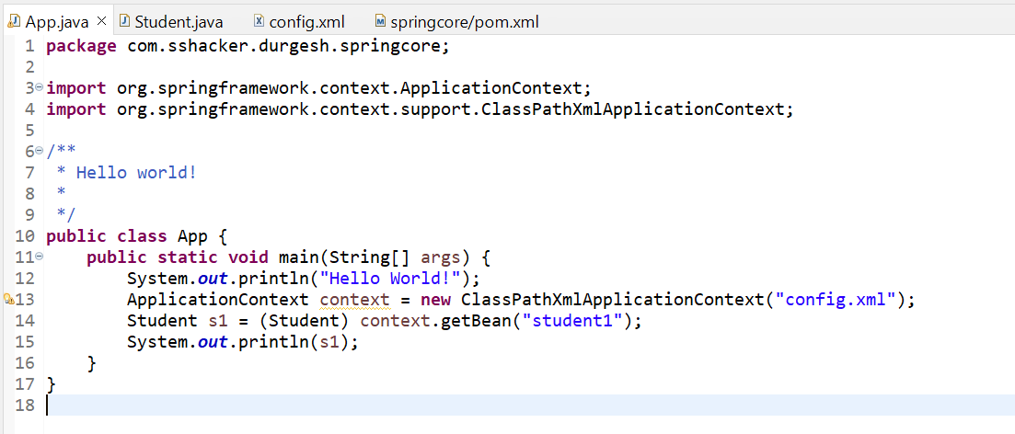

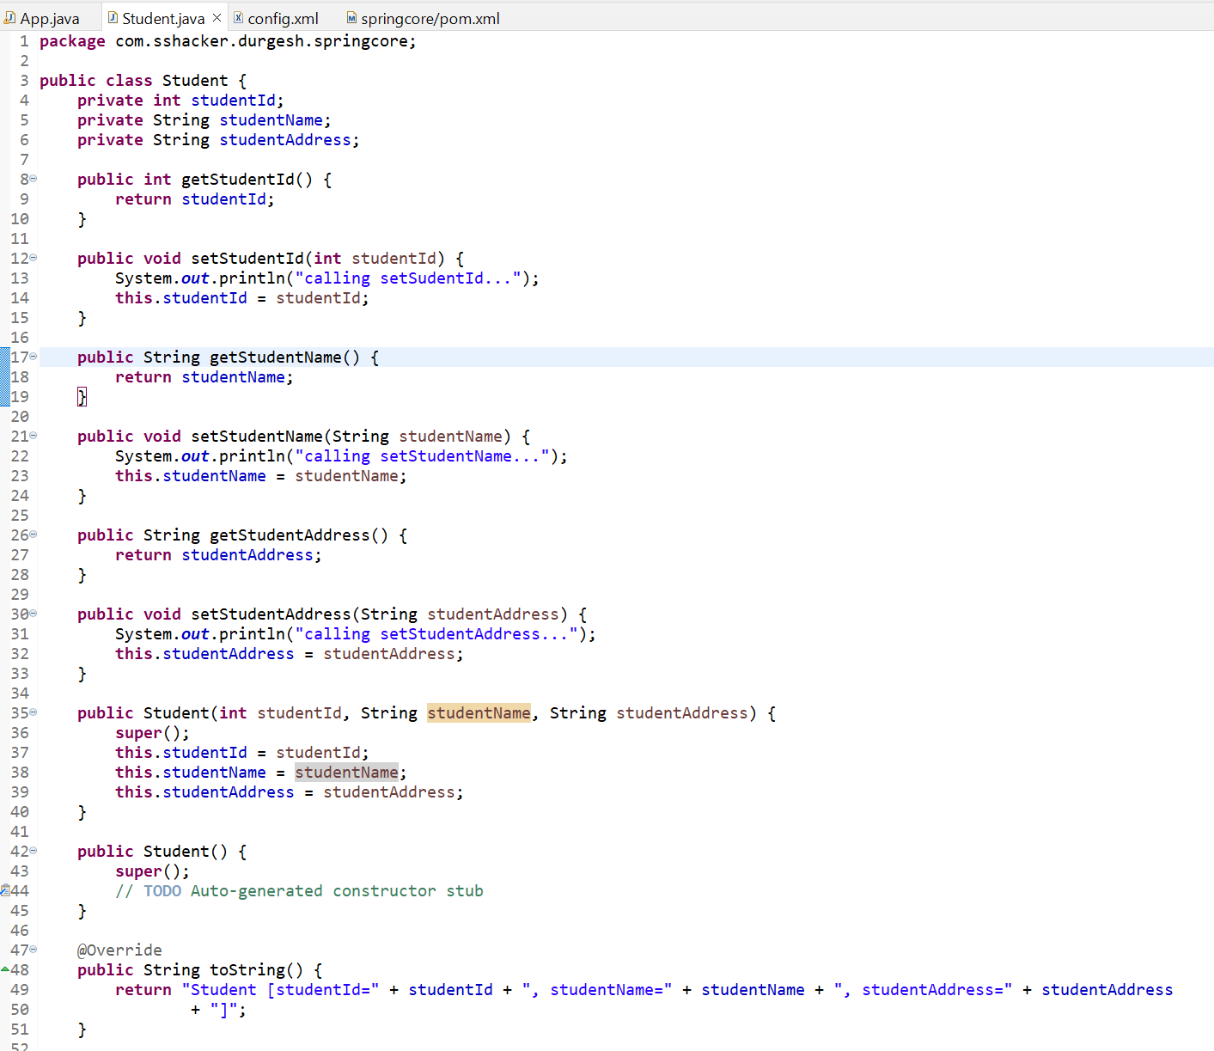

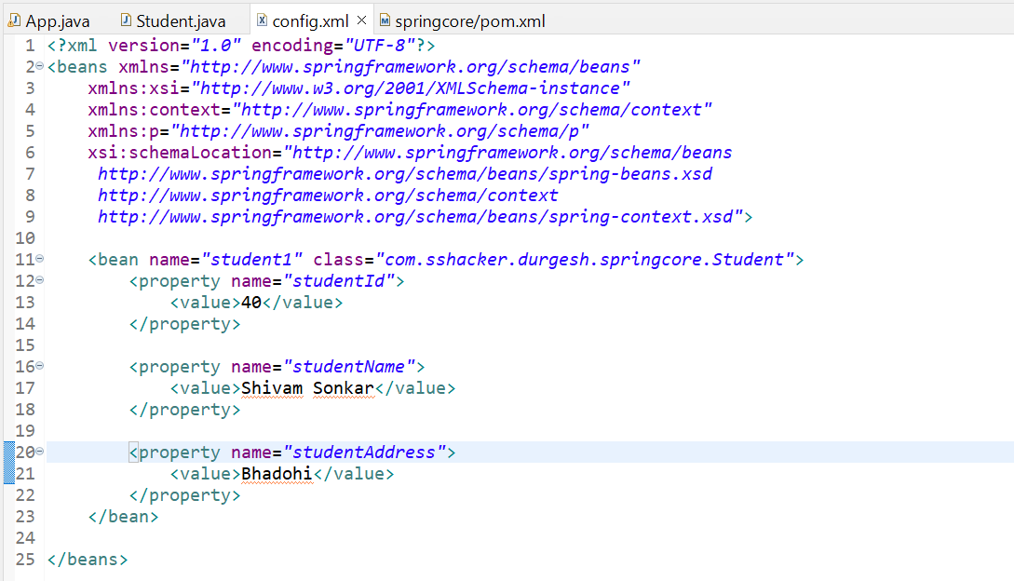

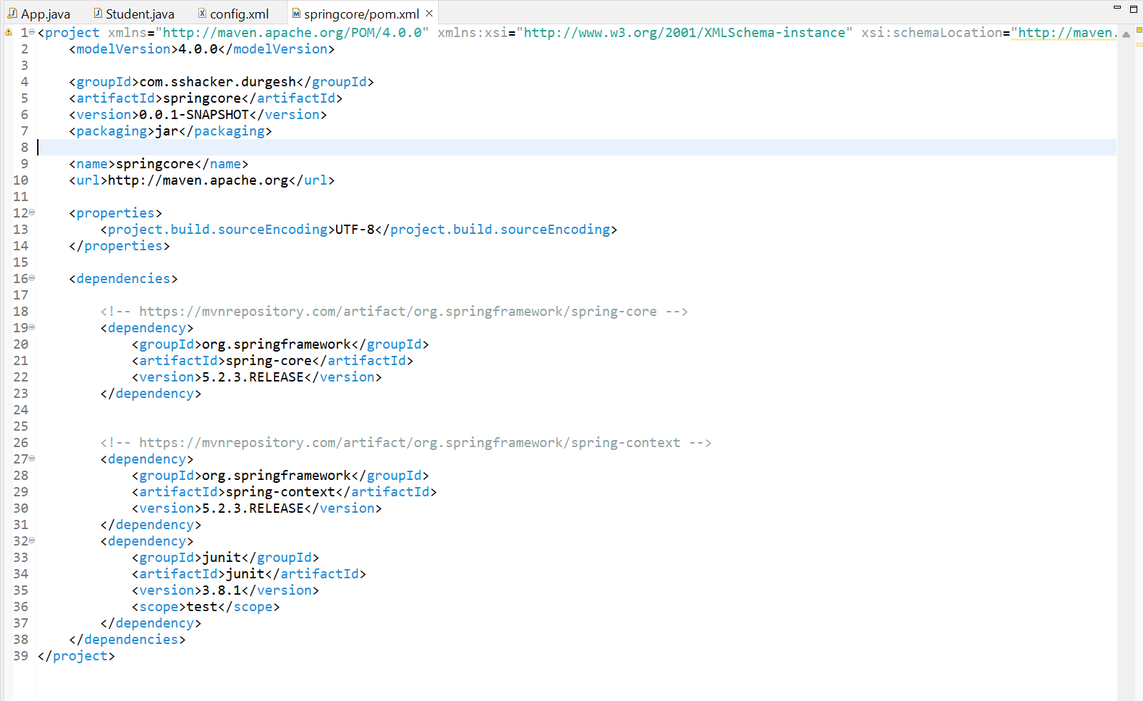

# Property injection using p Schema and using value as attribute | Spring tutorial

1. Using value as attribute: -

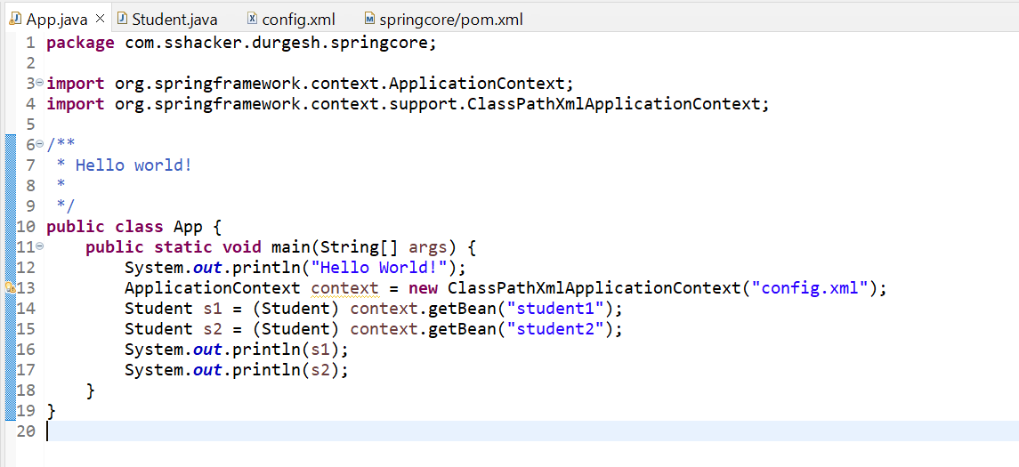

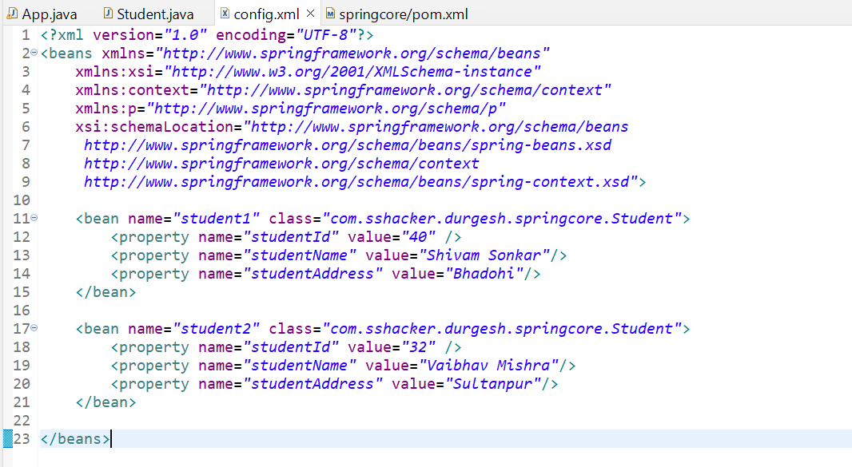

1. Using p schema: -

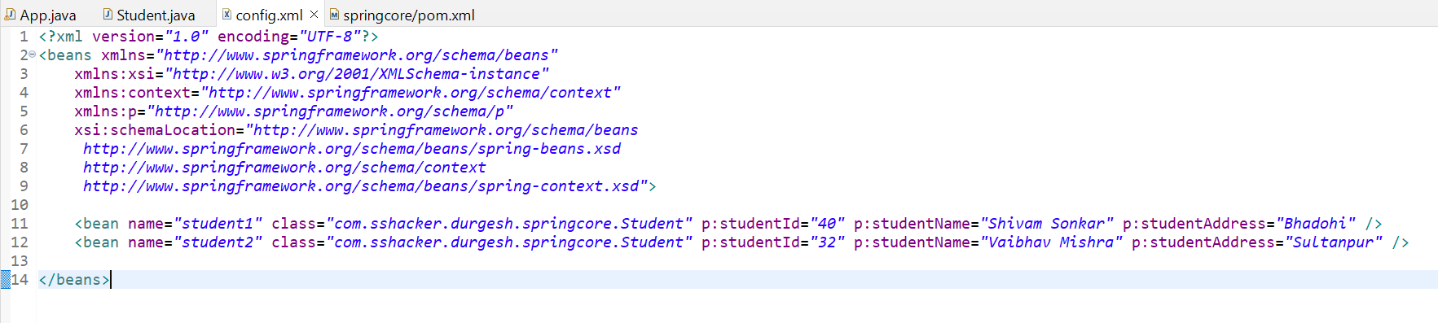

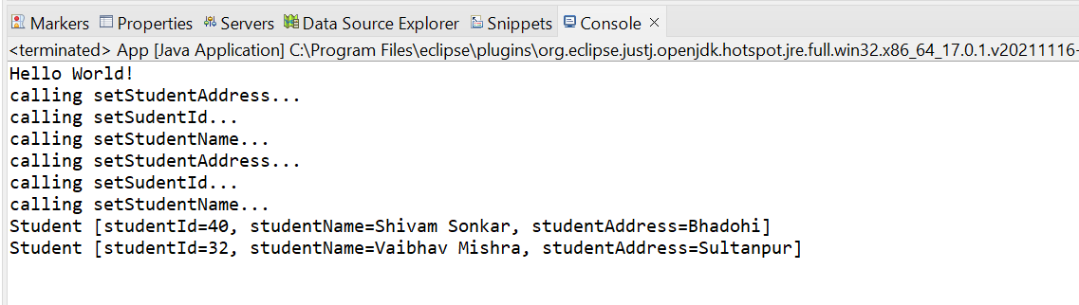

# 9. Injecting Collection Types[ List , Set , Map , Properties ] | Practical | Spring Framework Tutorial

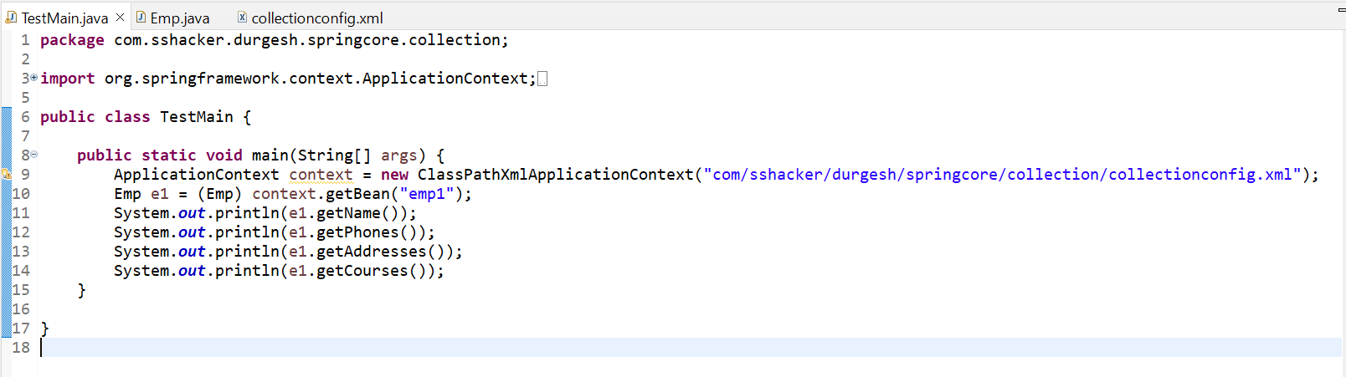

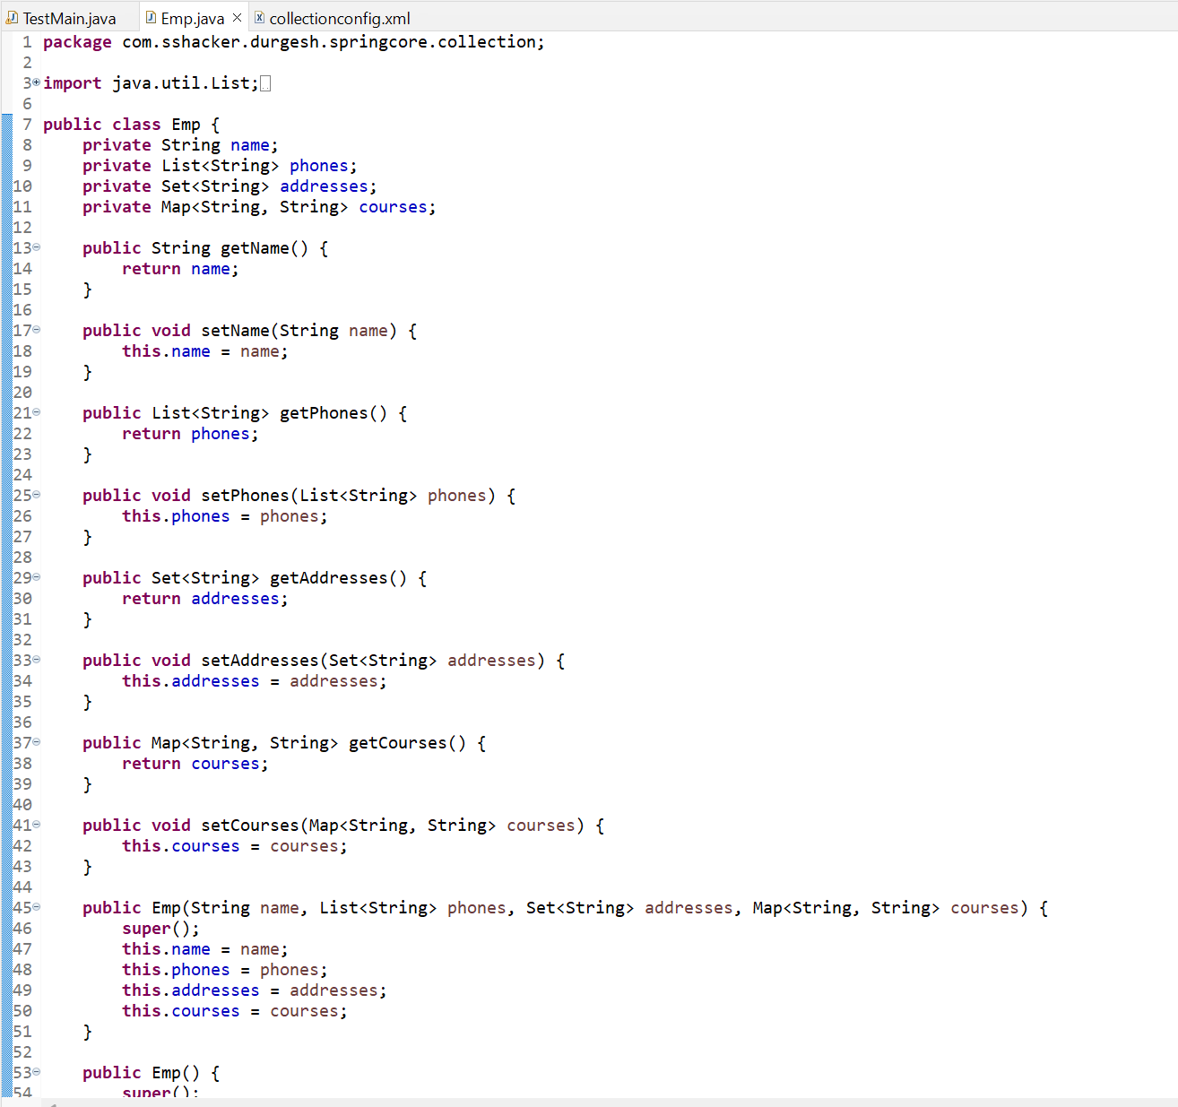

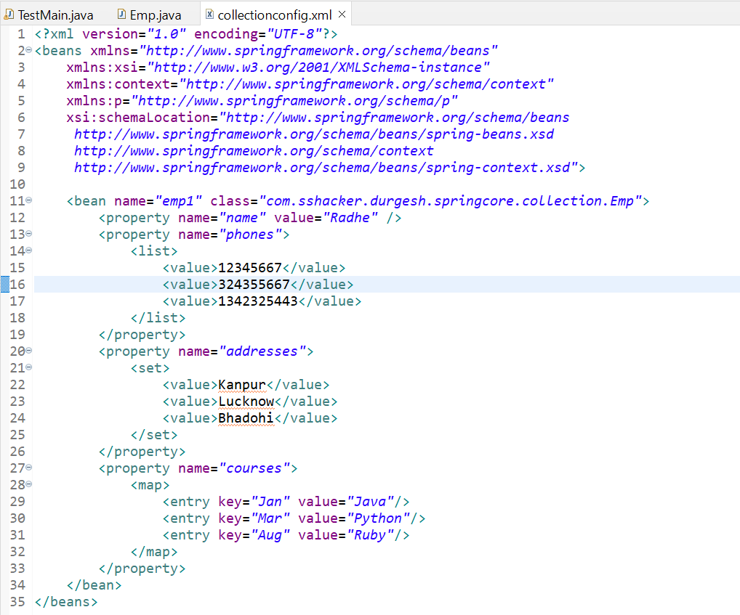

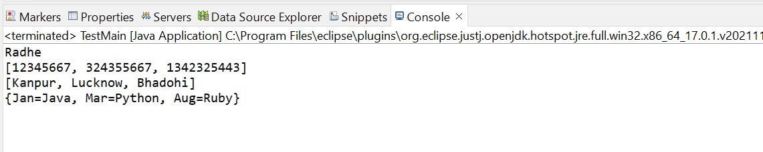

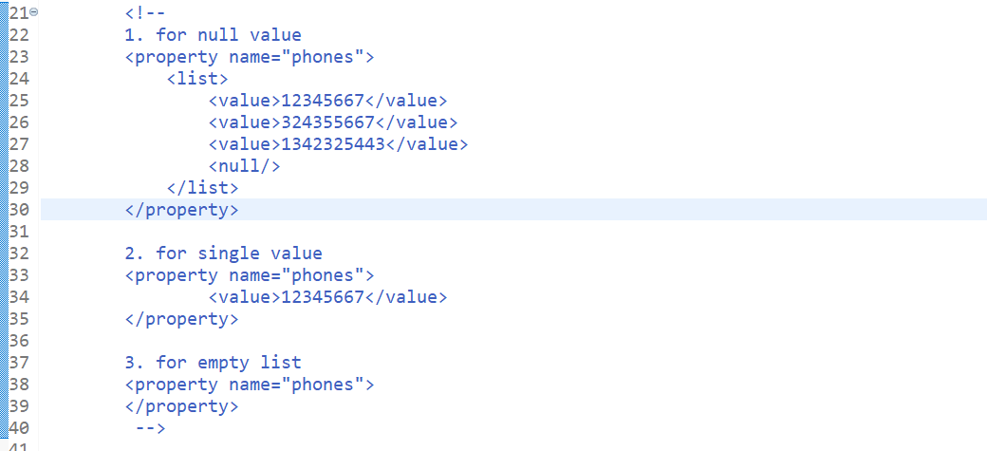

**For Properties Collection: -**

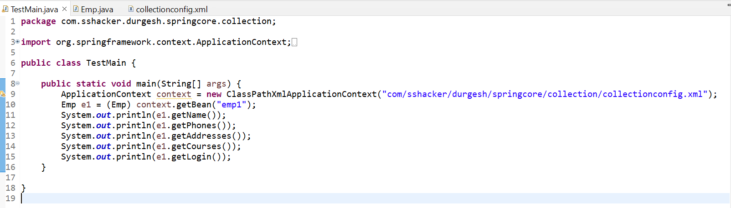

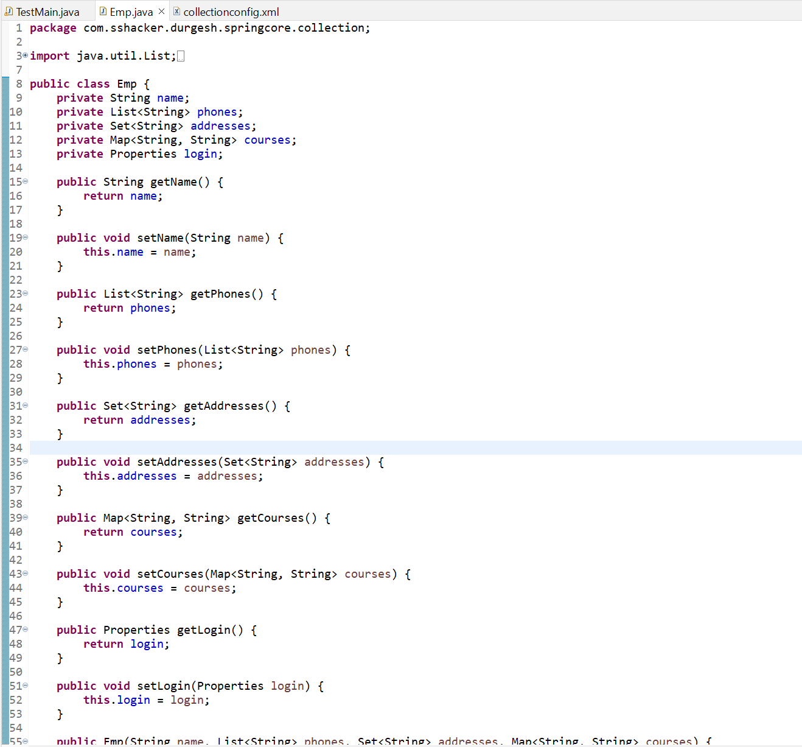

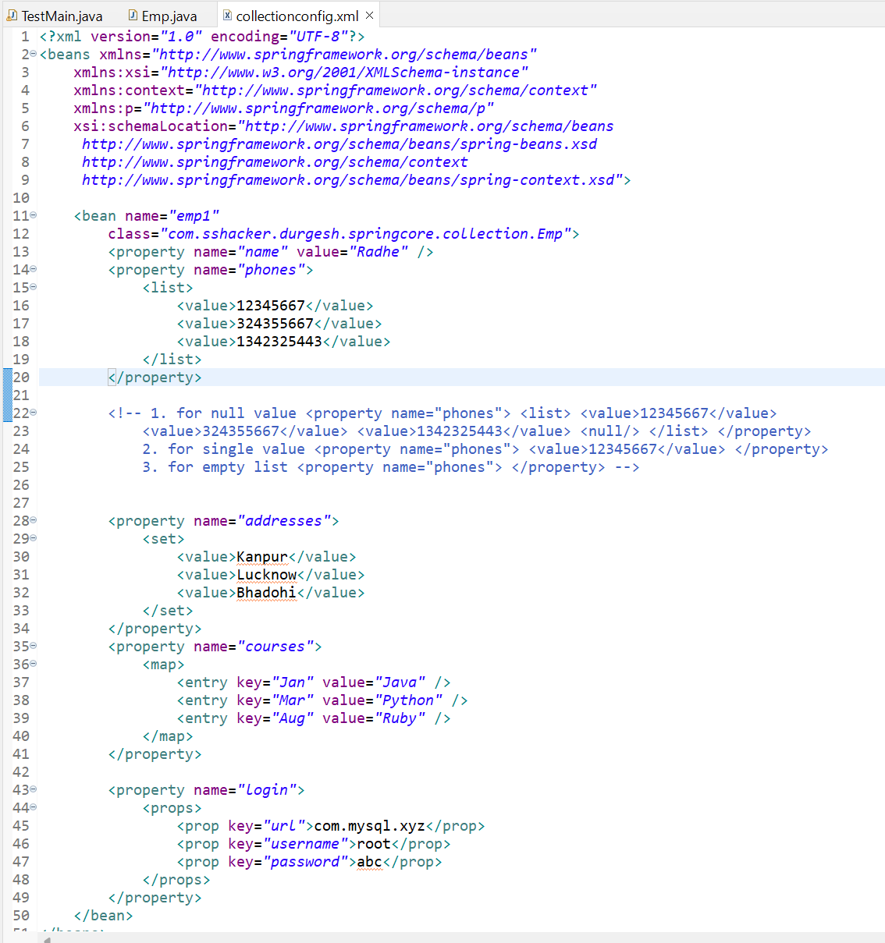

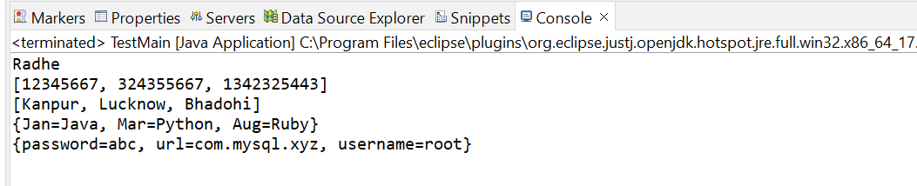

# 10. Injecting Reference Type Practical Video | Spring Framework Tutorial

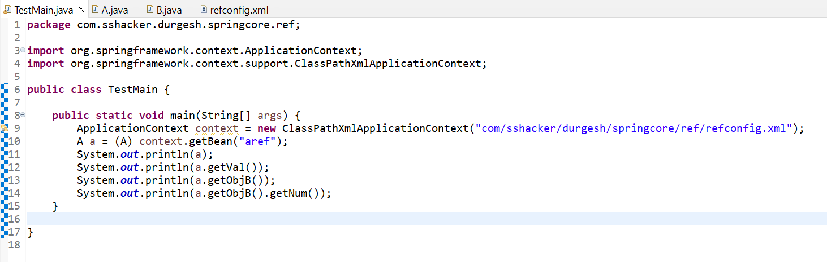

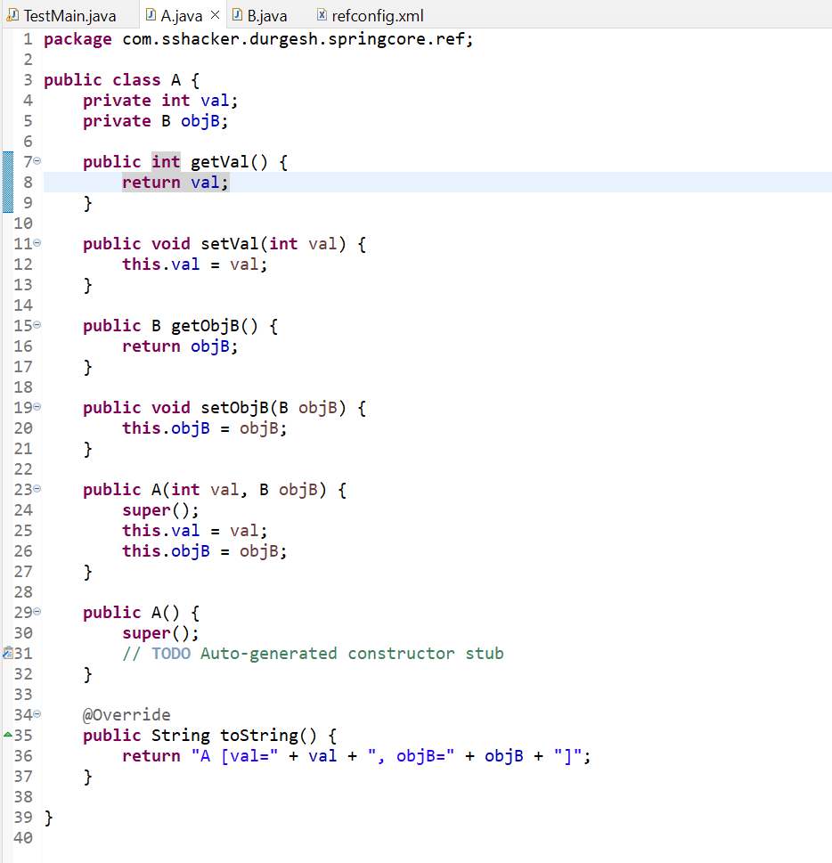

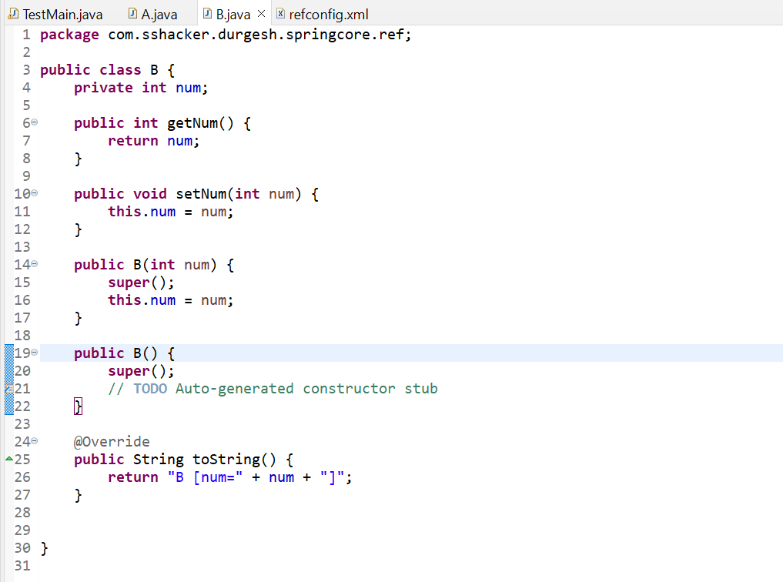

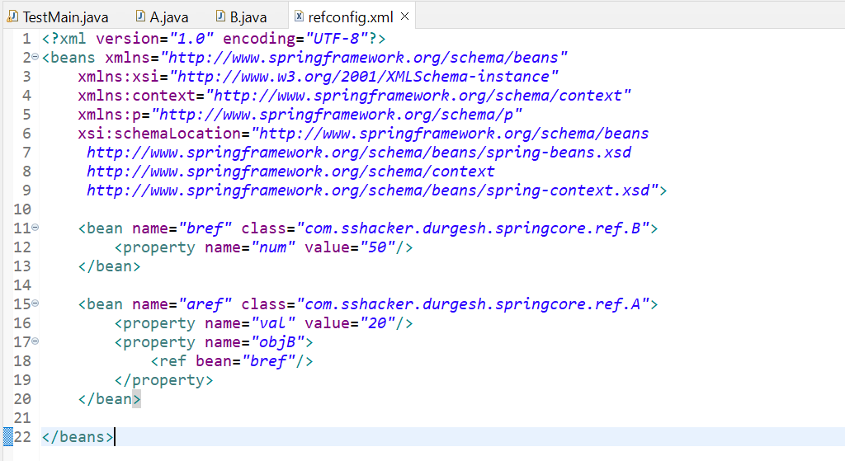

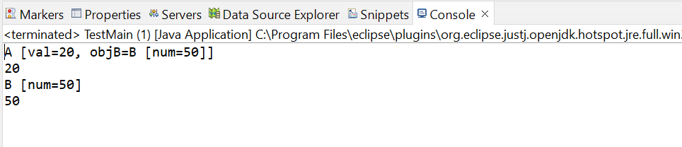

**Using ref as attribute and p schema**

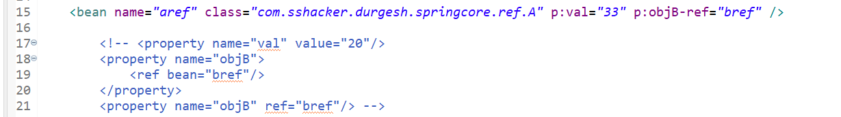

# 11. Constructor Injection Complete Explanation | Spring Framework Tutorial

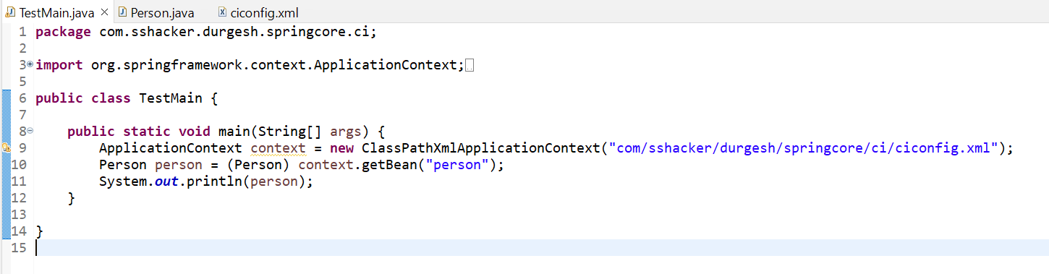

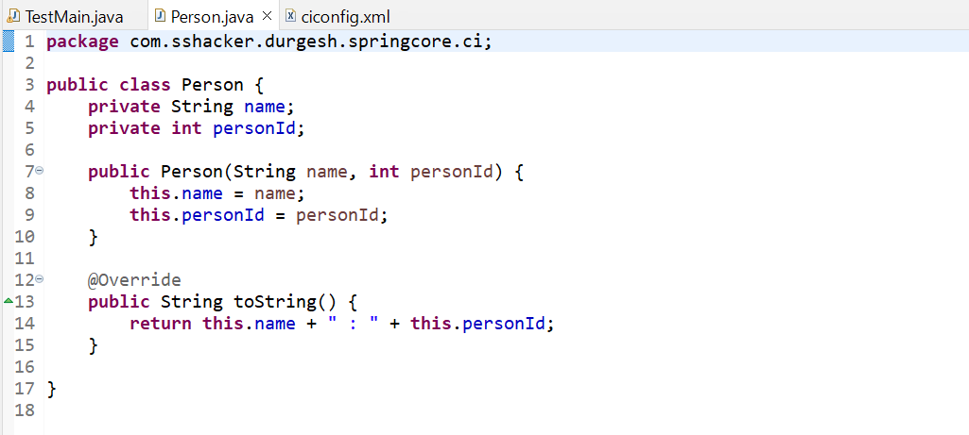

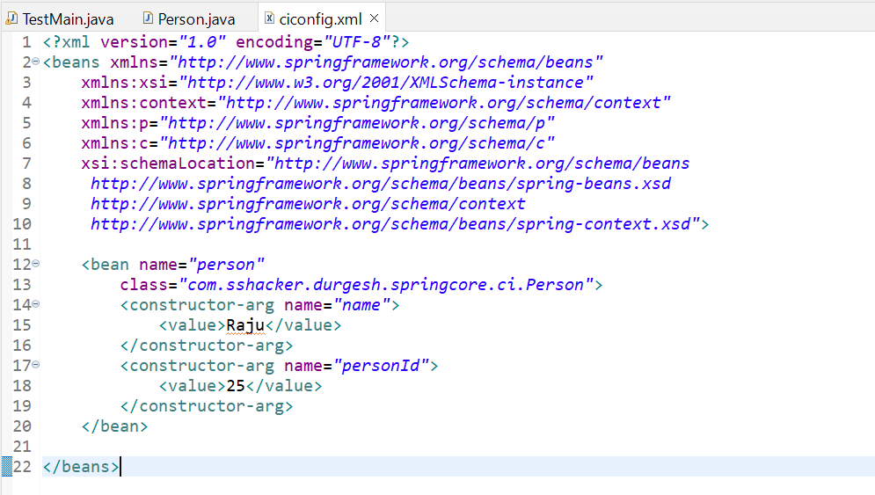

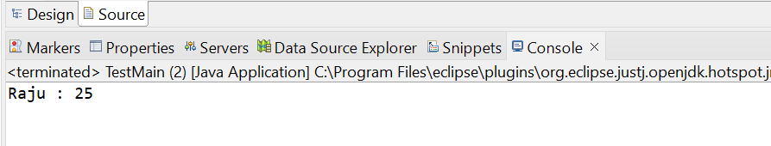

**Constructor Injection with ref**

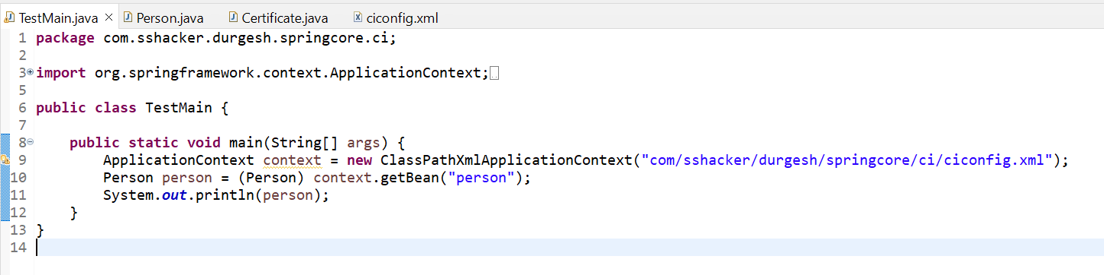

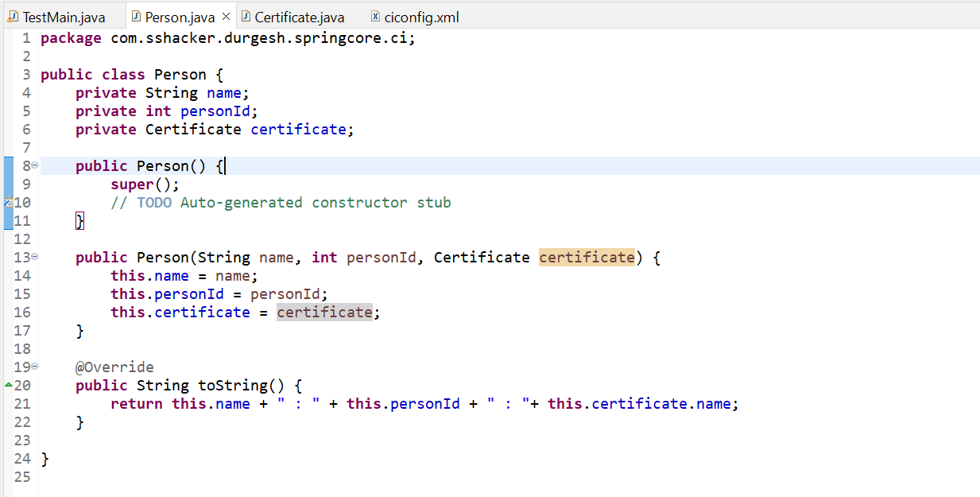

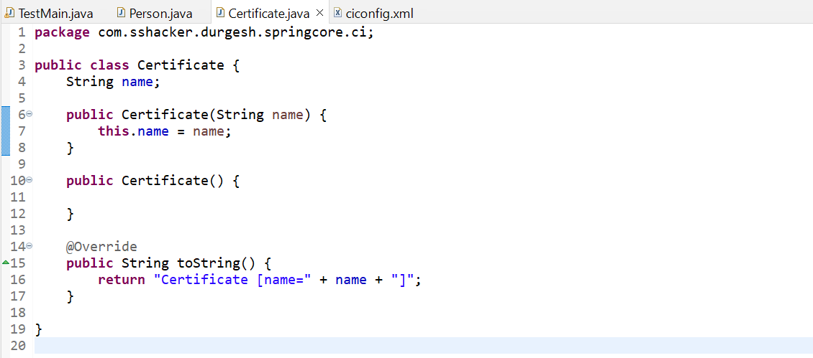

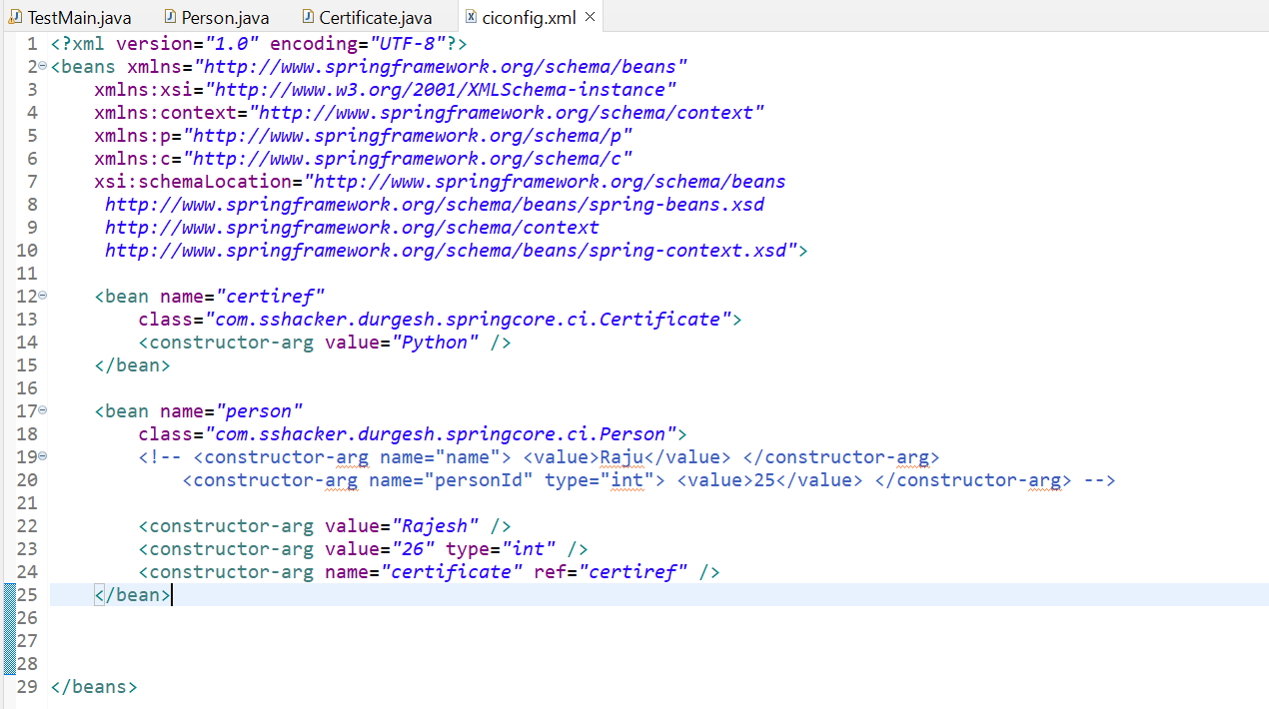

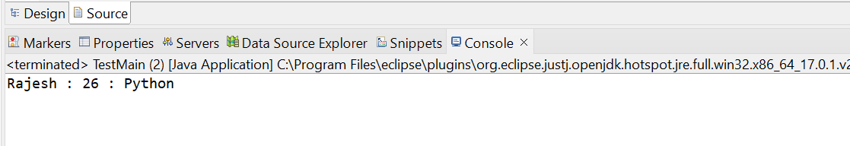

Passing list using Constructor injection: -

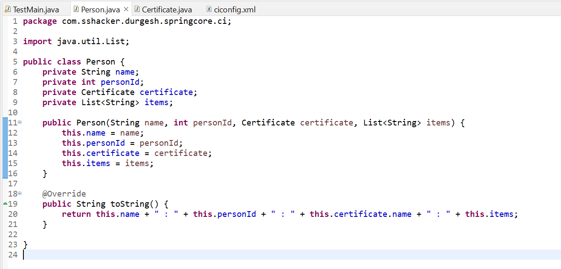

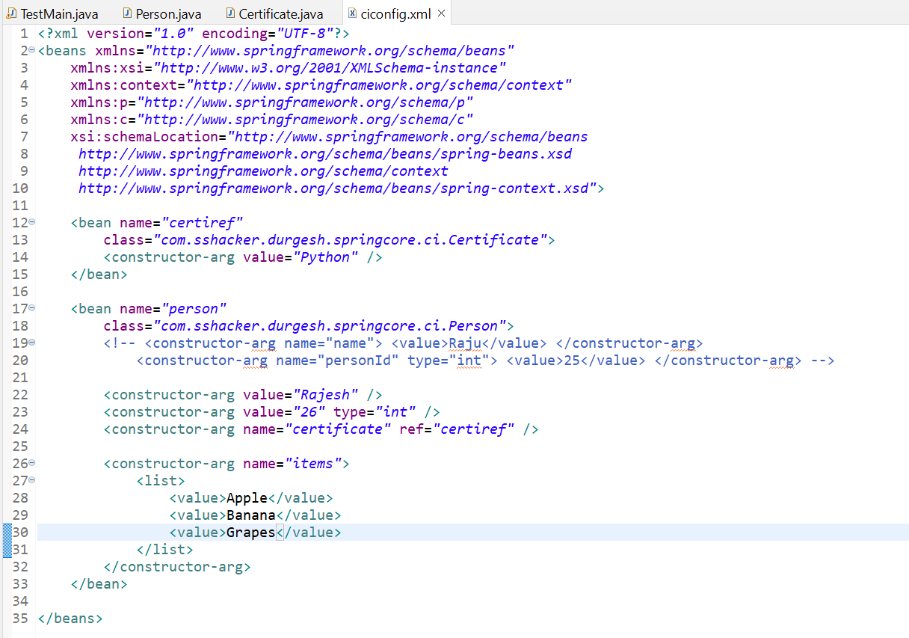

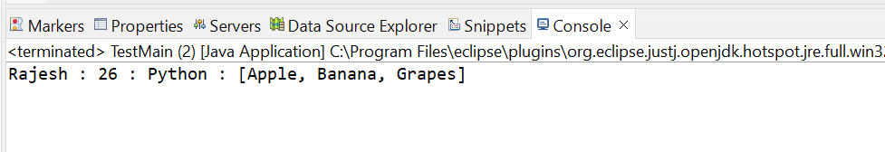

**Using c schema for Constructor injection: -**

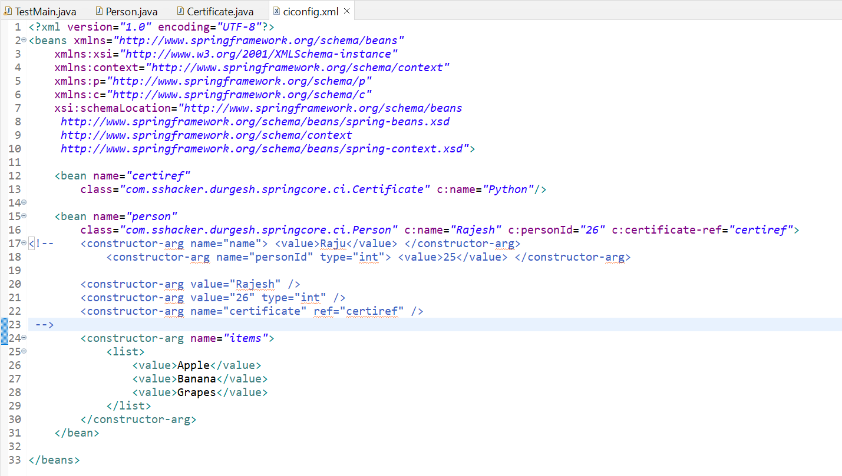

# 12. Ambiguity Problem and its Solution with Constructor Injection | Spring Framework Tutorial

Sequence Of Resolution: -

1. By exact match
2. By Type
3. By Index
4. By Order

**By Order: -**

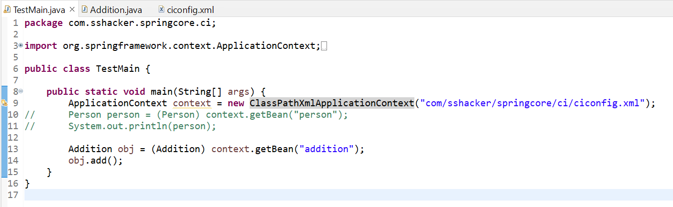

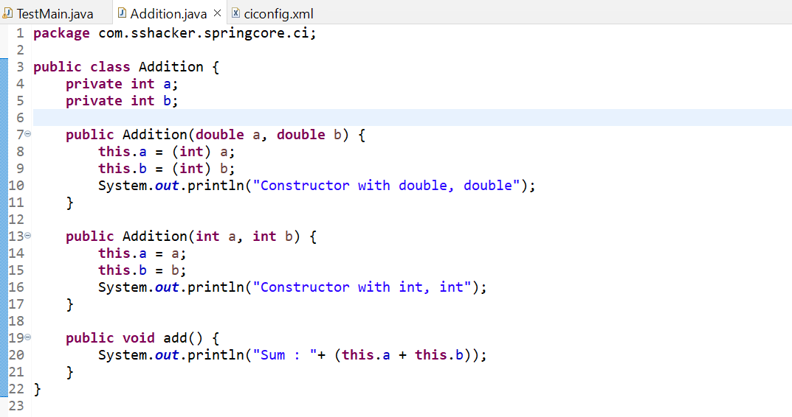

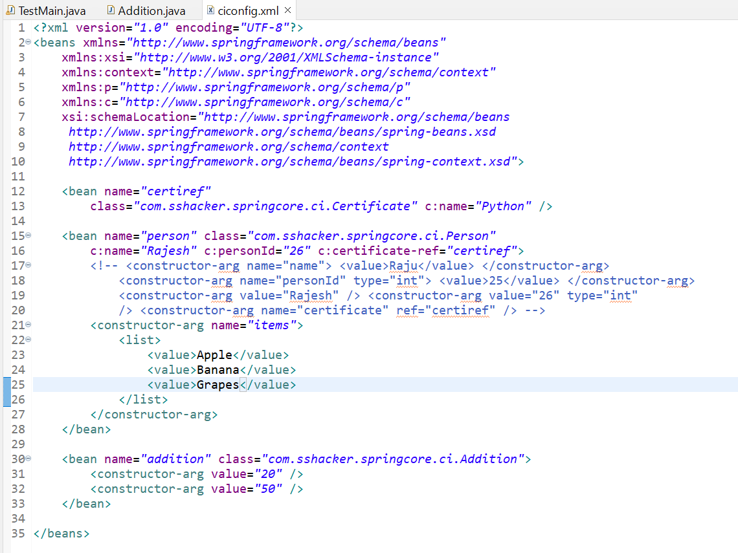

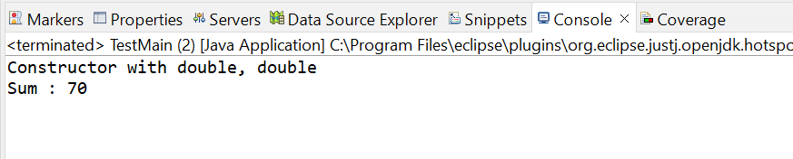

**By exact match: -**

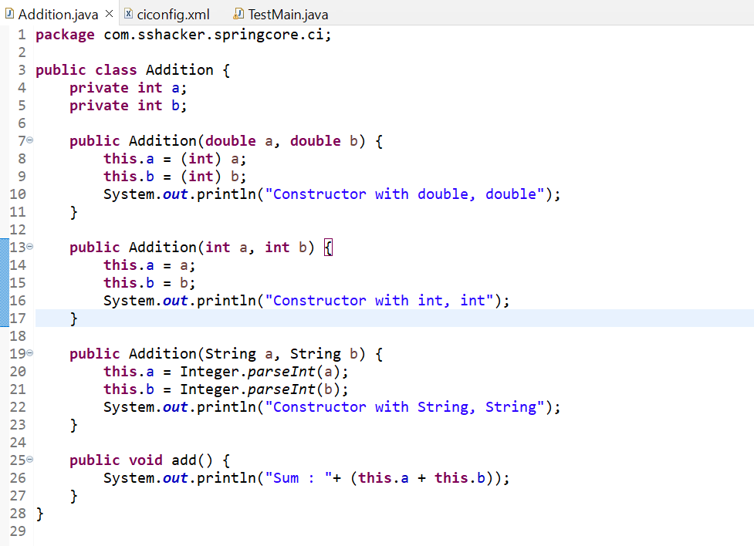

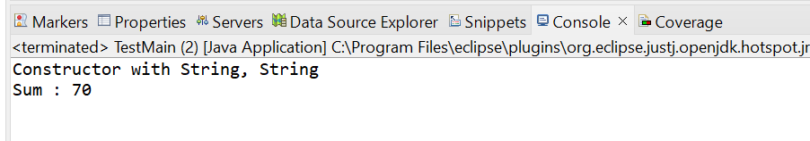

**By Type: -**

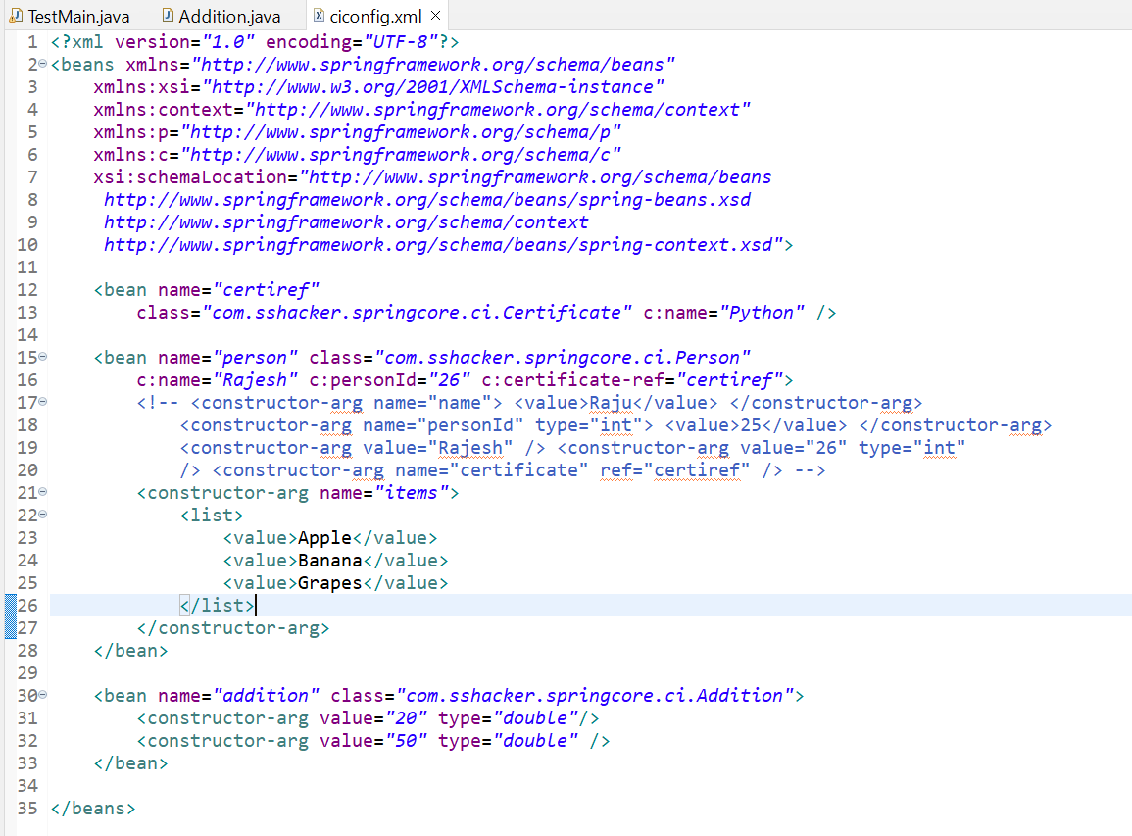

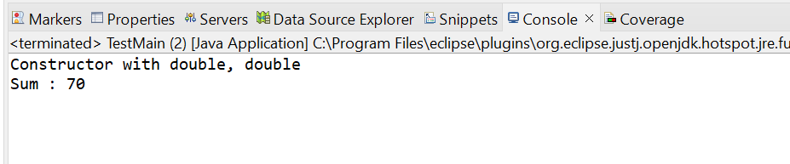

**By Index: -**

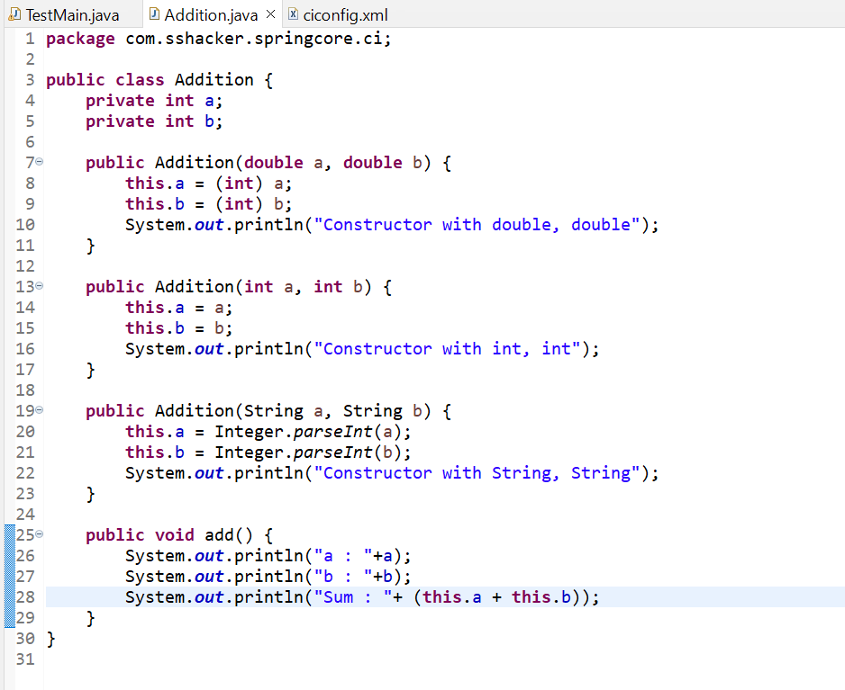

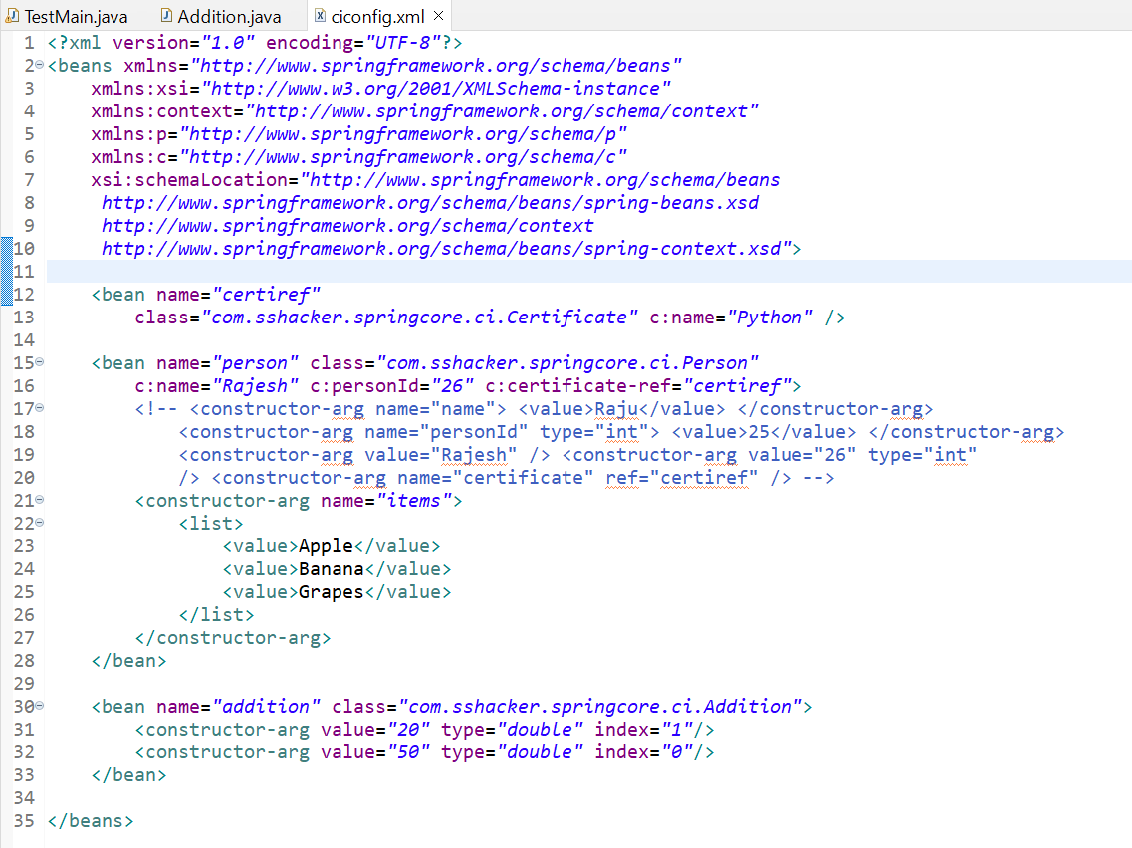

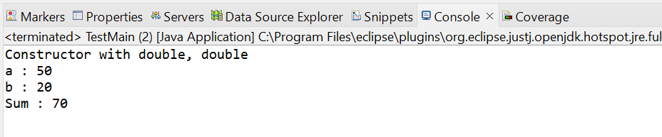

# 14. Implementing Lifecycle methods Using XML | Spring Bean Lifecycle methods | Spring Framework Tut

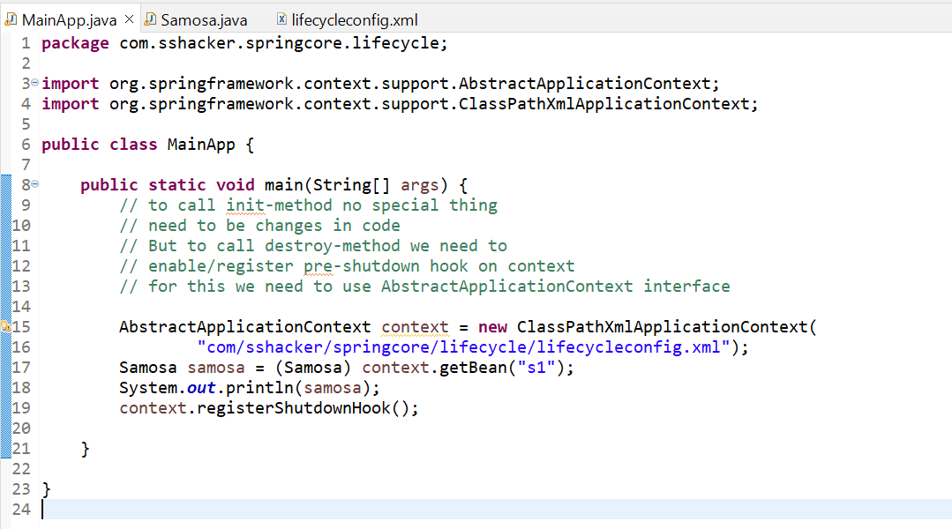

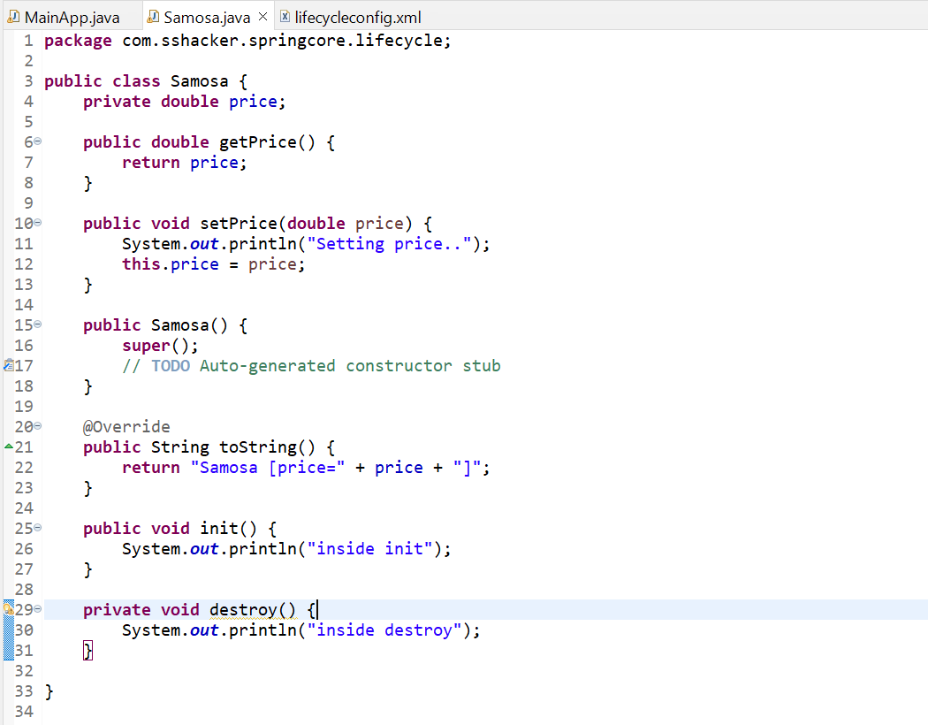

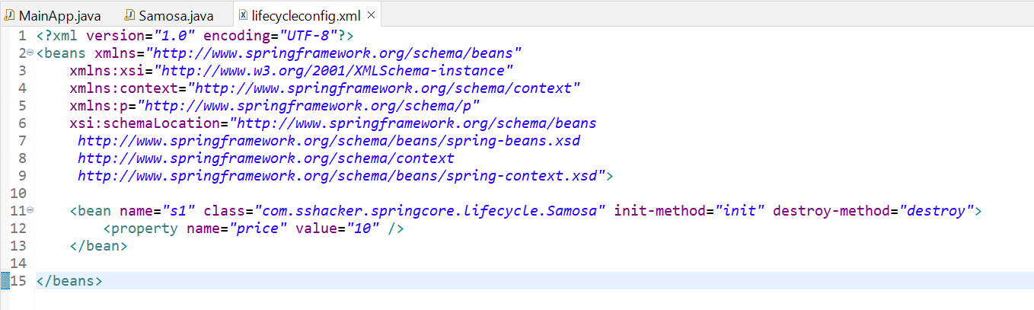

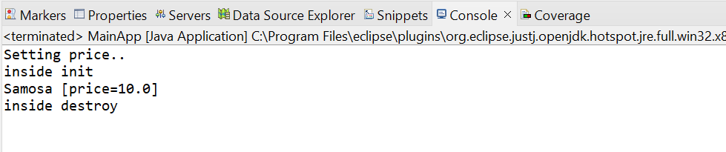

**By taking any name for init and destroy method: -**

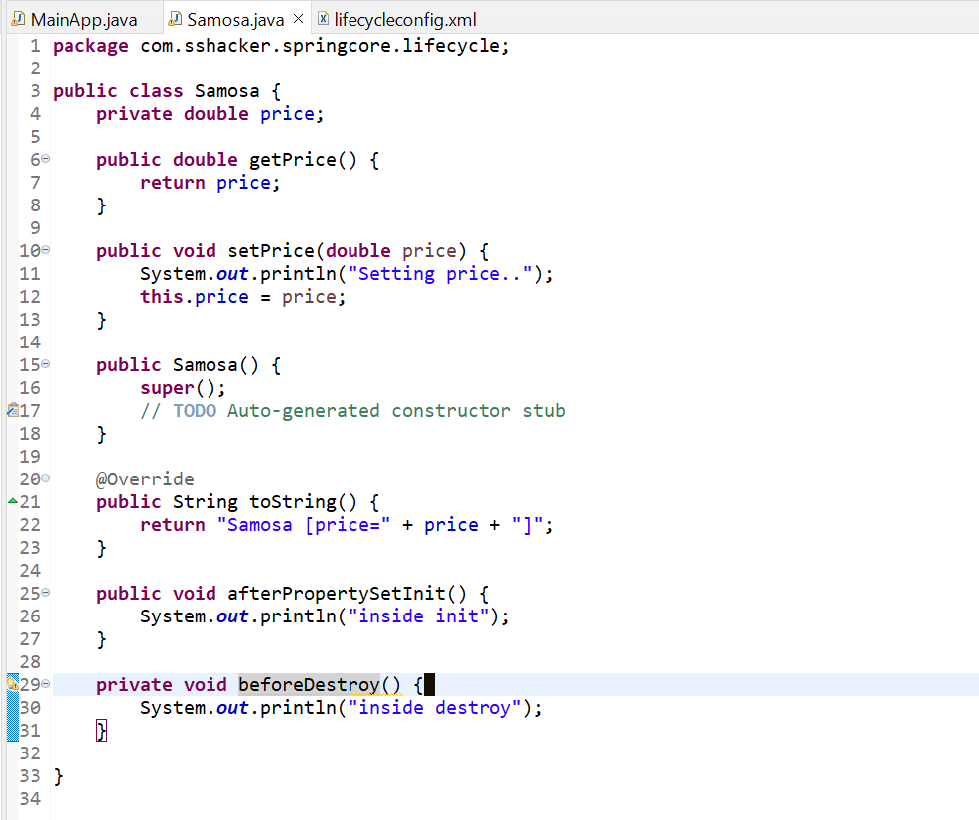

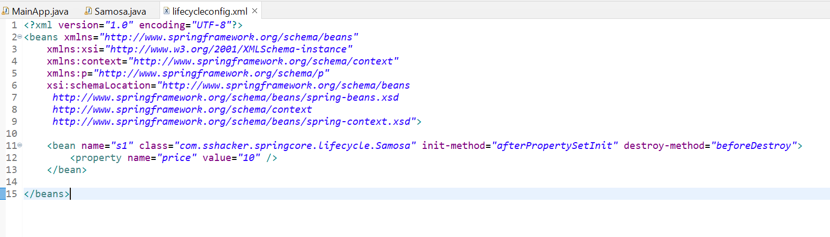

# 15. Implementing bean life cycle using interfaces | IntializingBean | DisposableBean | Spring Tutorial

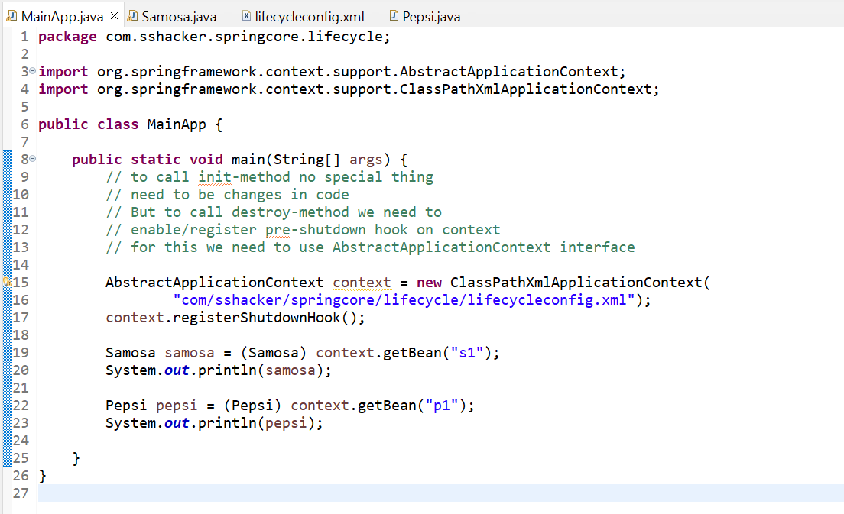

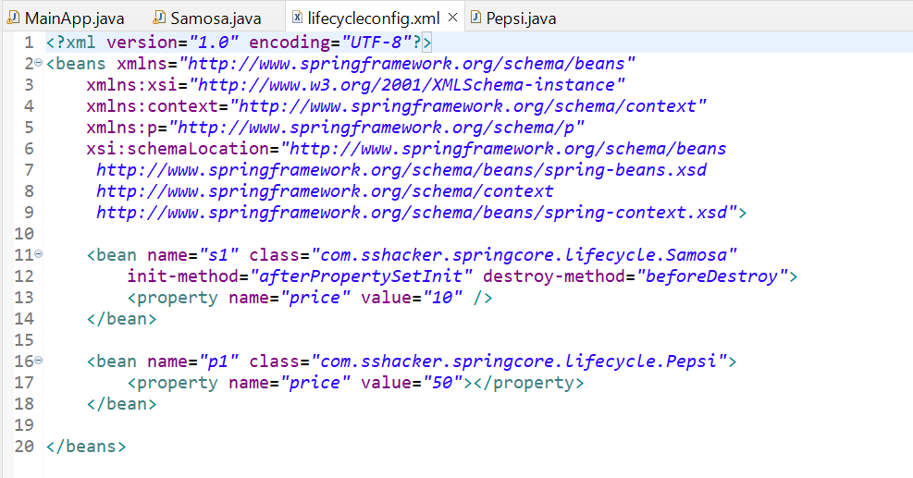

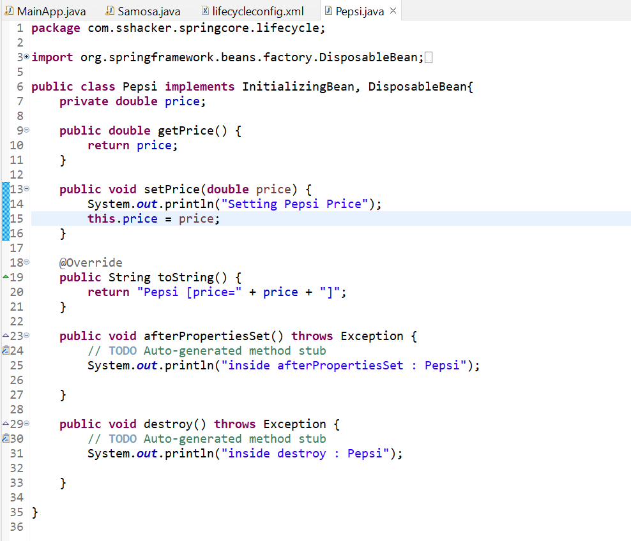

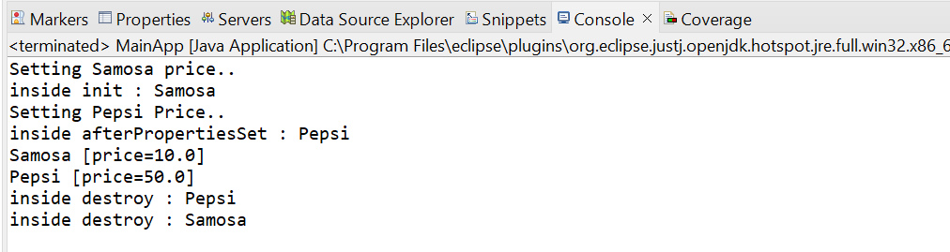

# 16. Implementing Bean LifeCyle using Annotations | @PostConstruct | @PreDestroy | Spring Tutorial

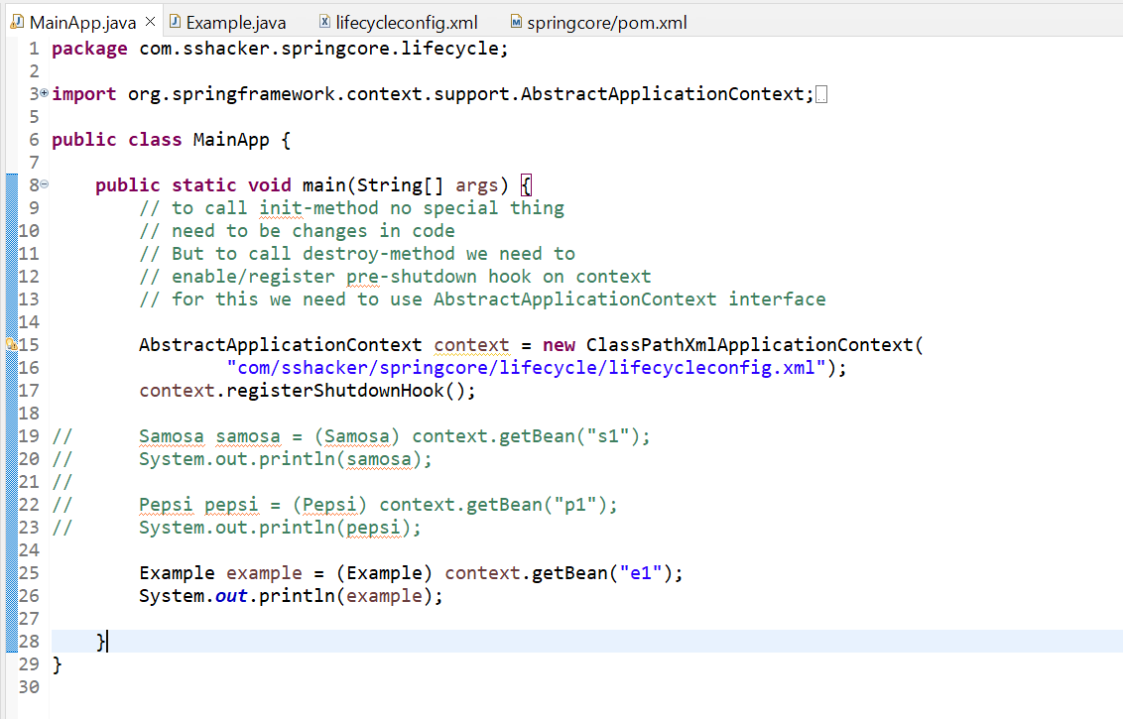

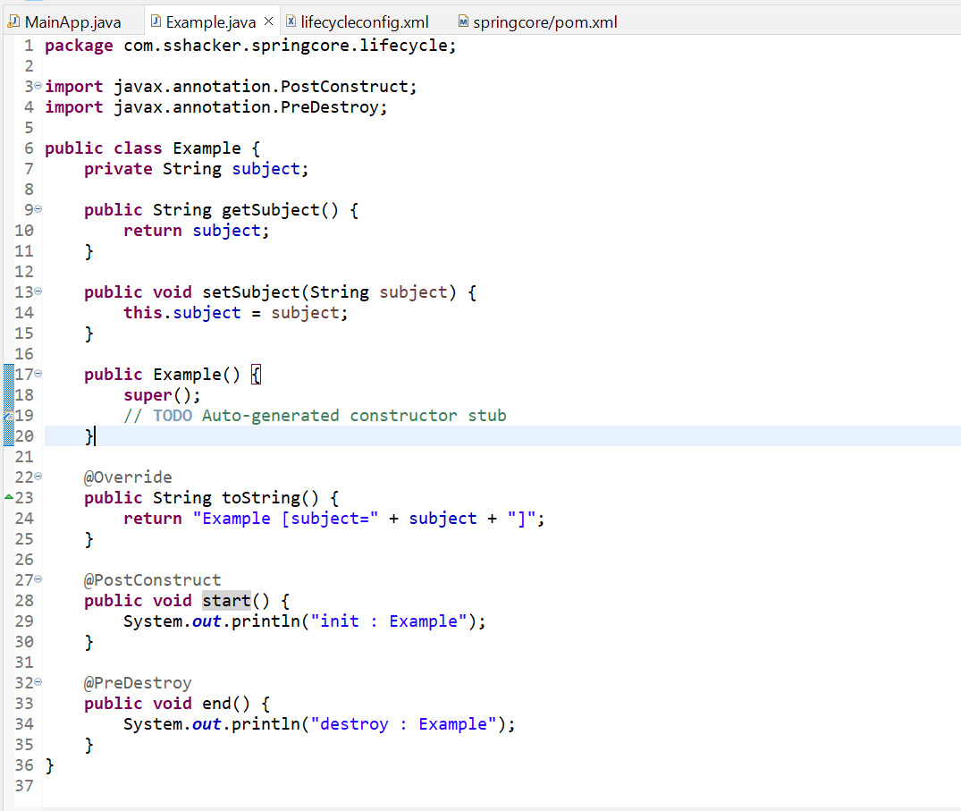

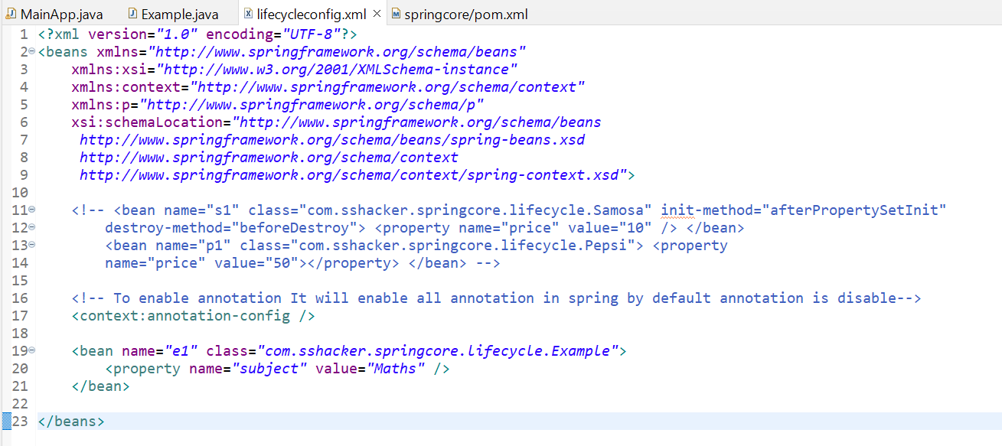

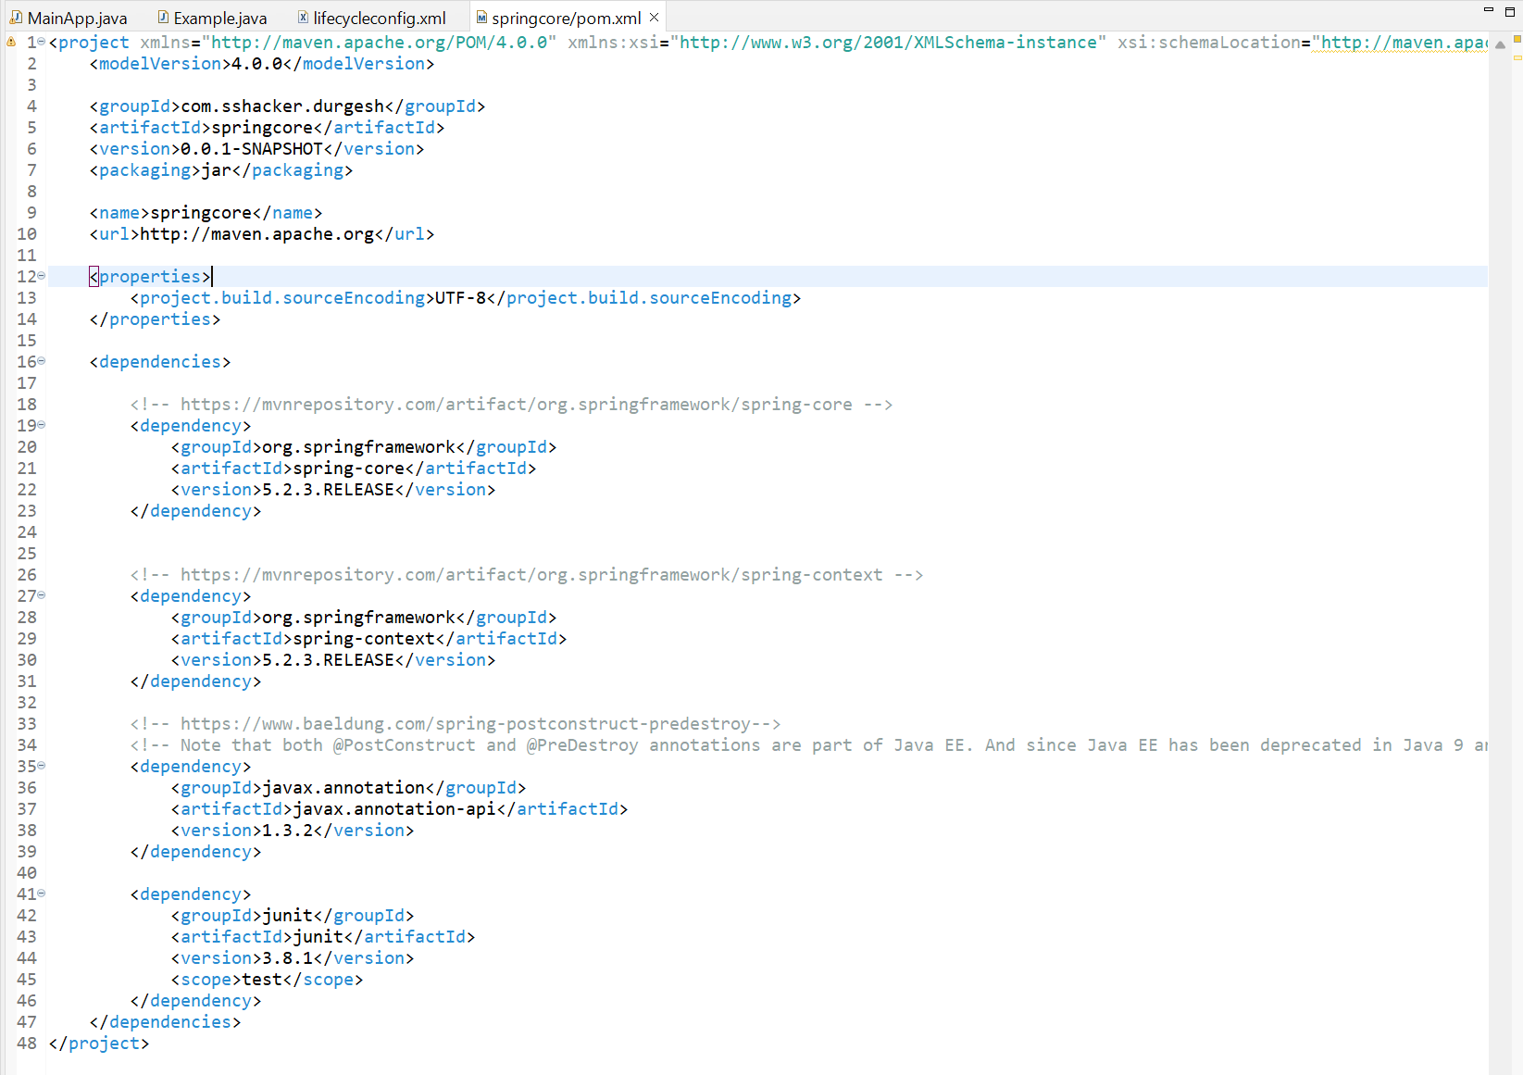

To enable annotation for @PostConstruct and @PreDestroy only not for all annotation: -

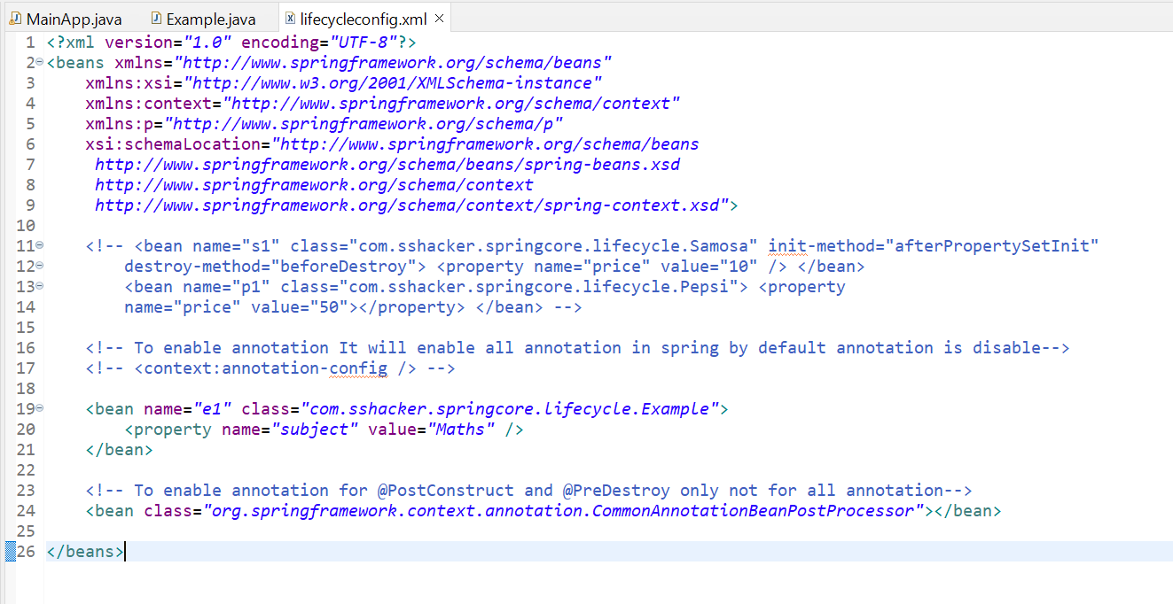

# 18. Autowiring using XML complete Session | byName | byType | byConstructor | Spring Tutorial

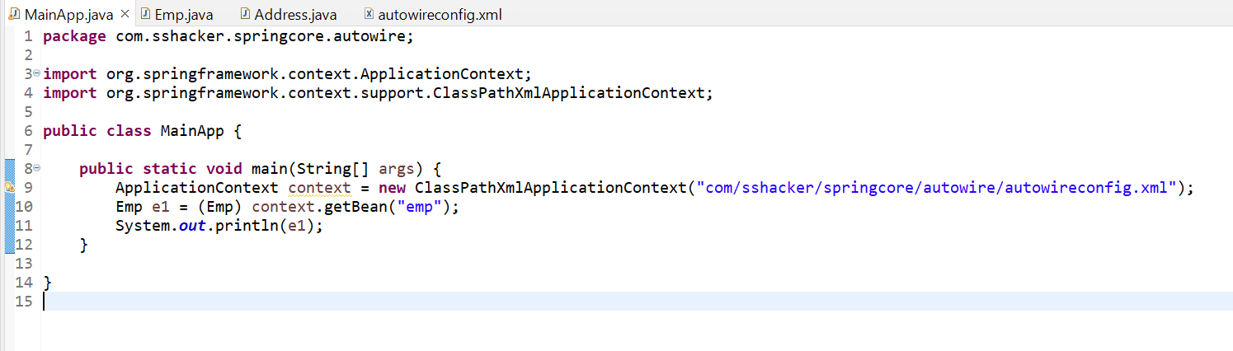

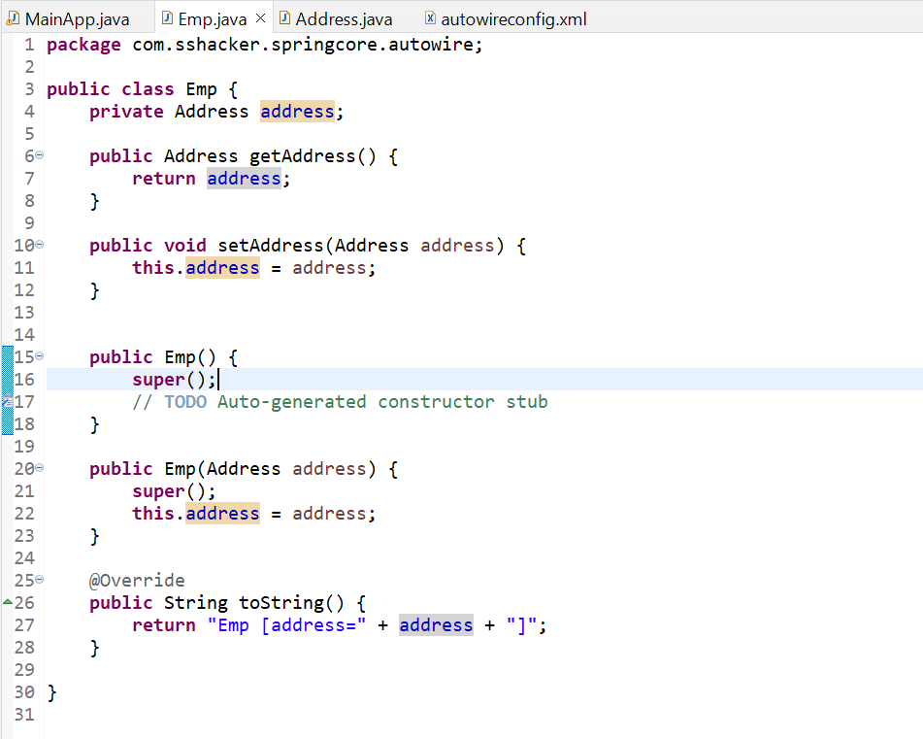

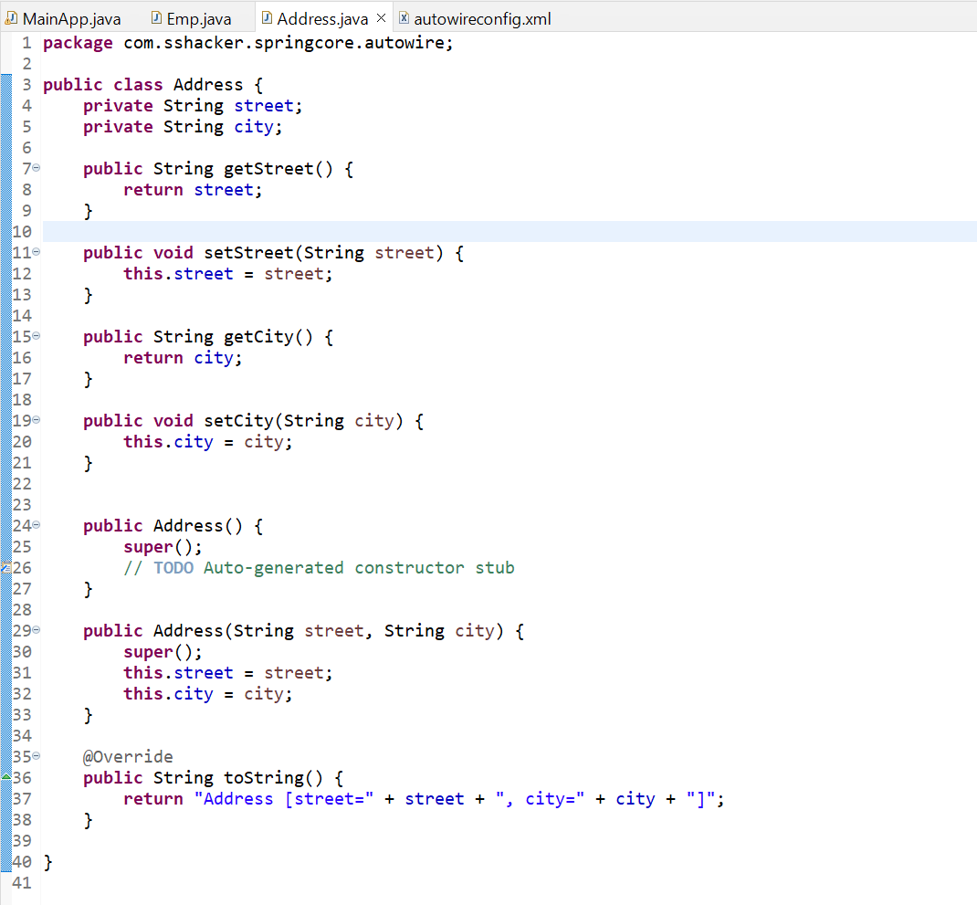

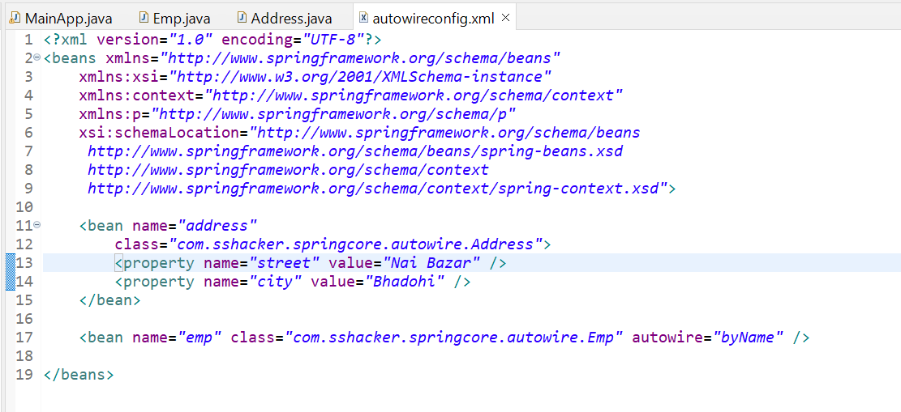

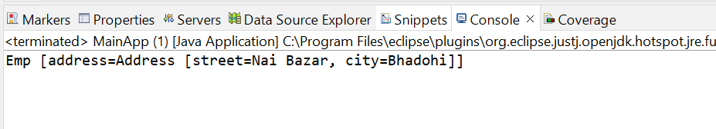

If bean name is not match with variable reference name there will be no error it just returns null.

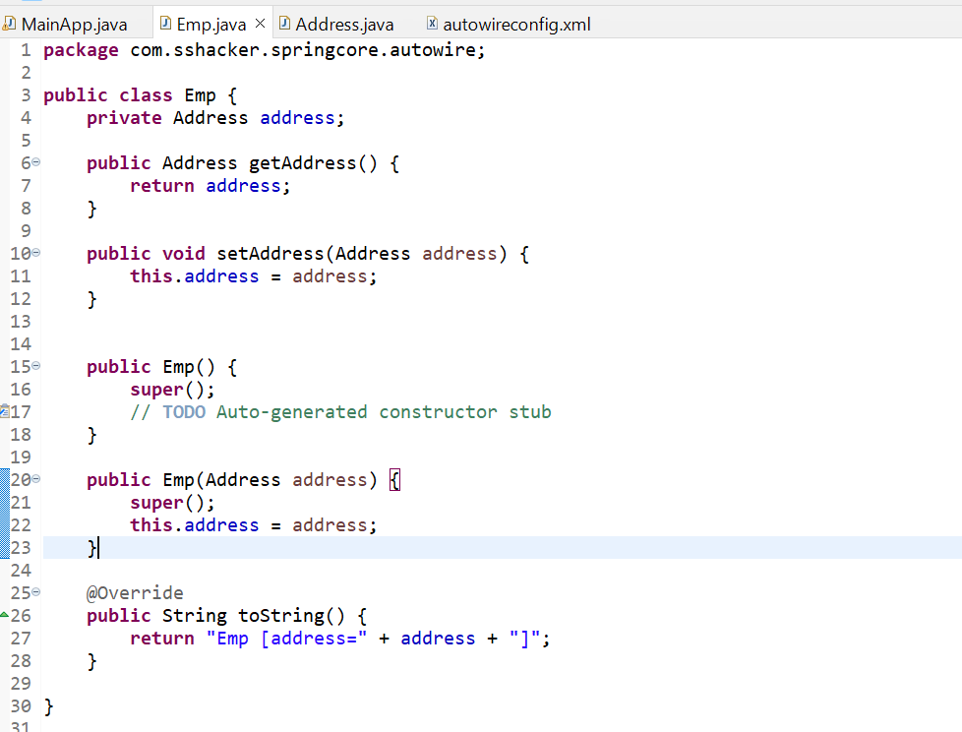

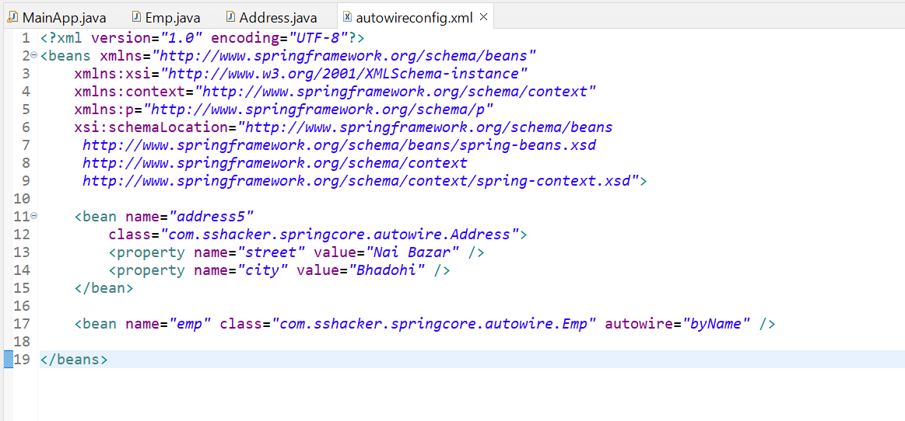

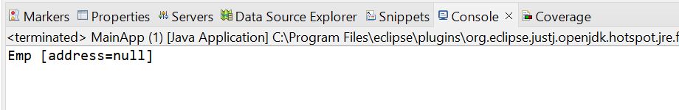

Autowire=”byType” : -

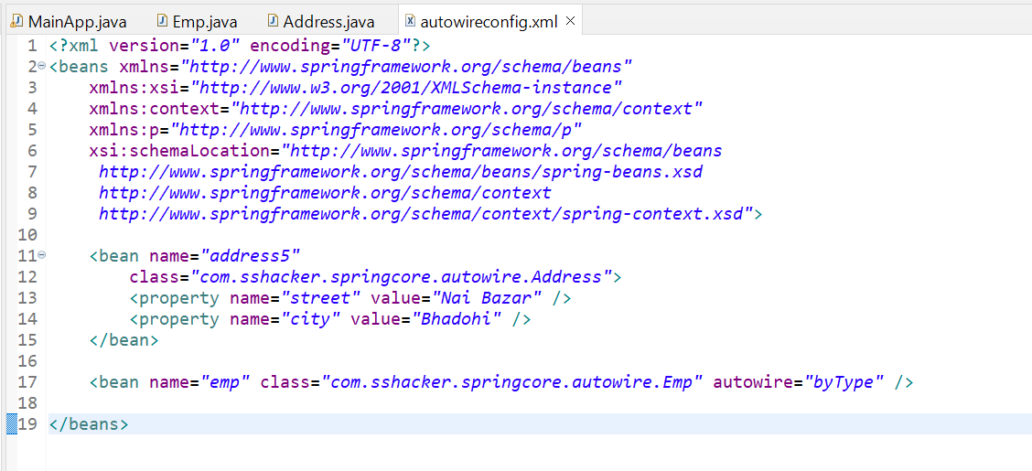

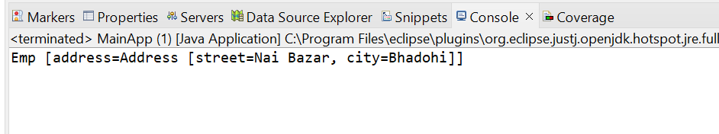

Conflict issue due to byType: -

NoUniqueBeanDefinitionException

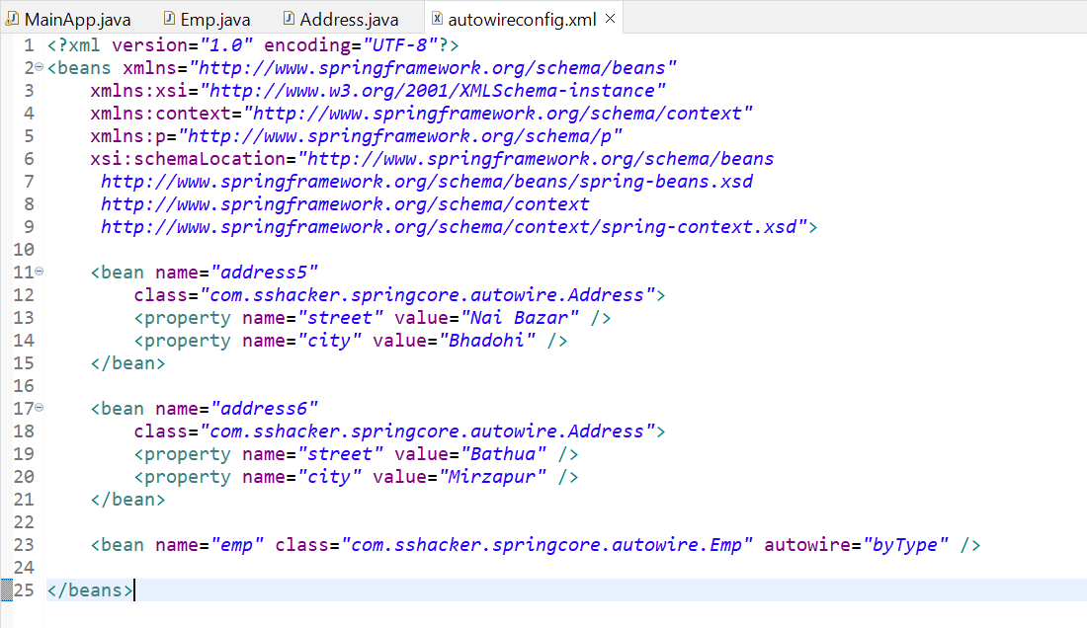

Constructor: -

It will check byName and call parameterized constructor also.

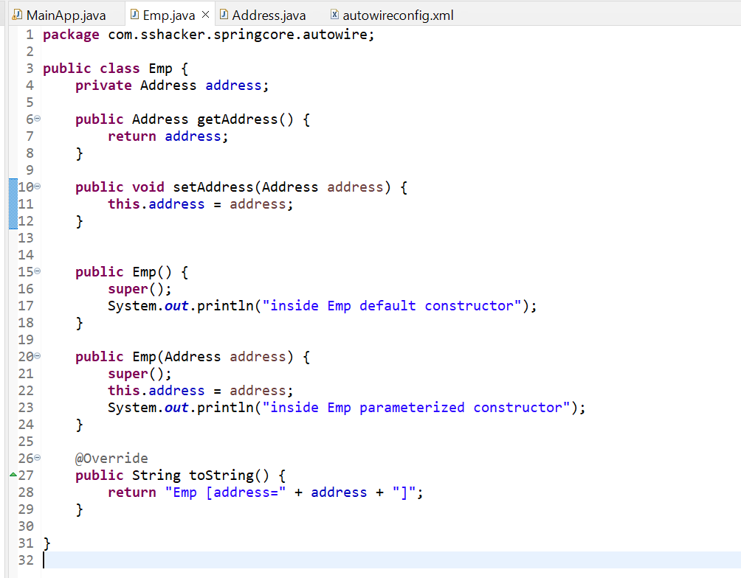

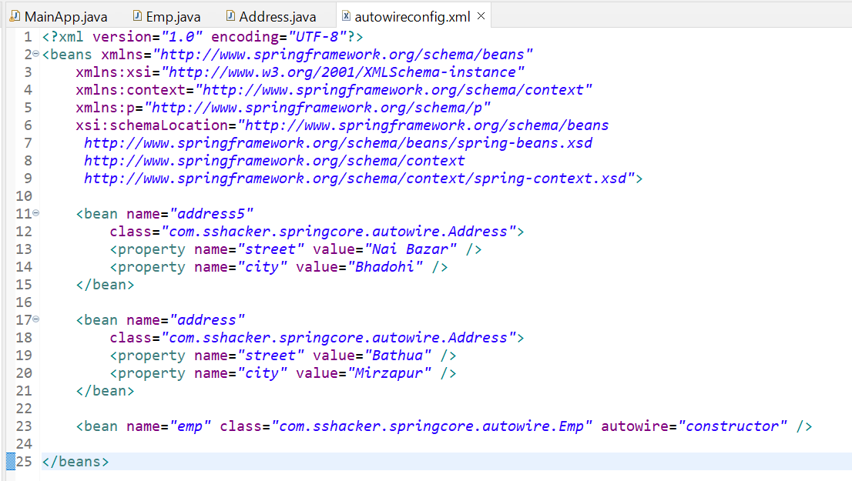

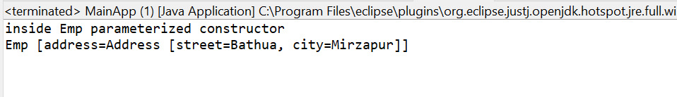

Constructor: -

It will check byName and call parameterized constructor also. If byName no bean found then it return null (no exeption or error raise).

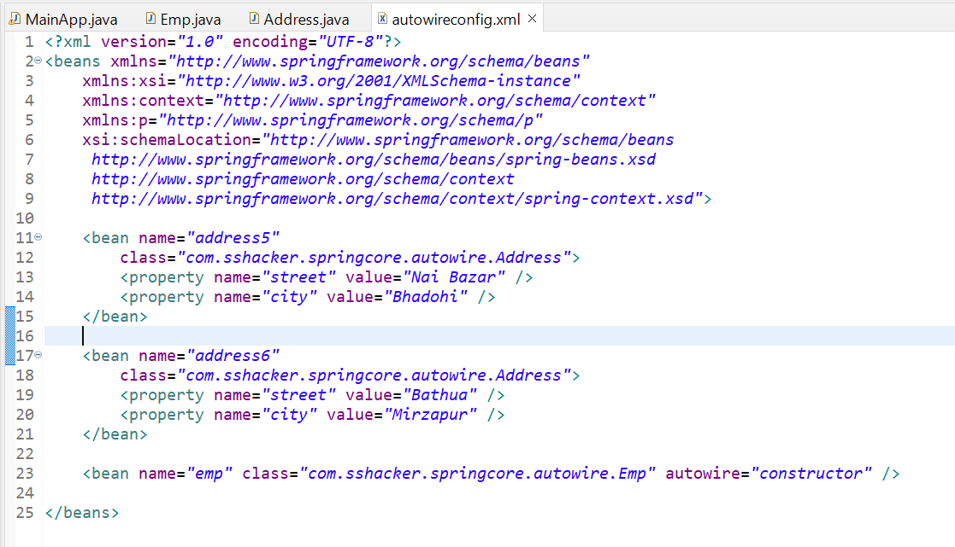

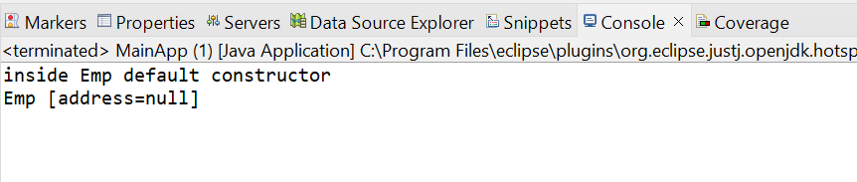

# 19. @Autowired Annotation for Autowiring | Autowiring in Spring Framework | Spring Framework Tutorial

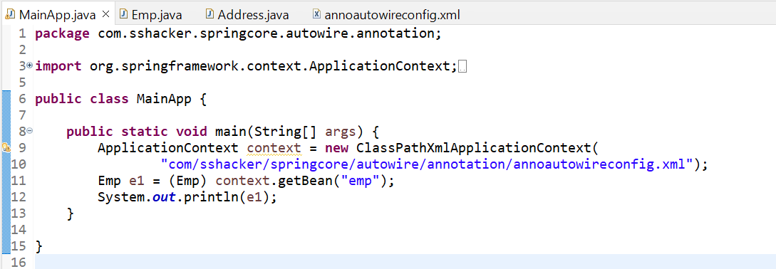

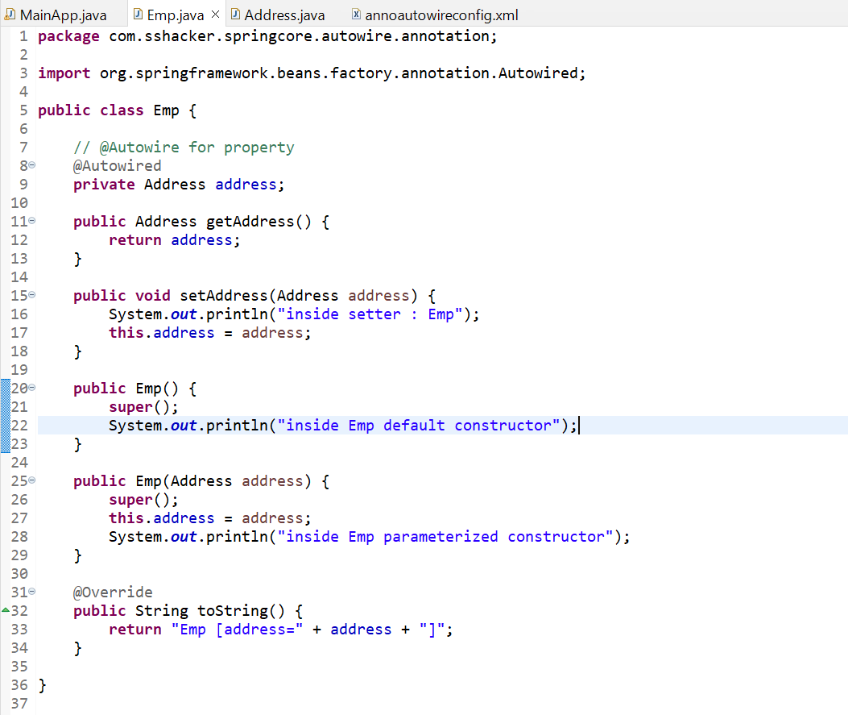

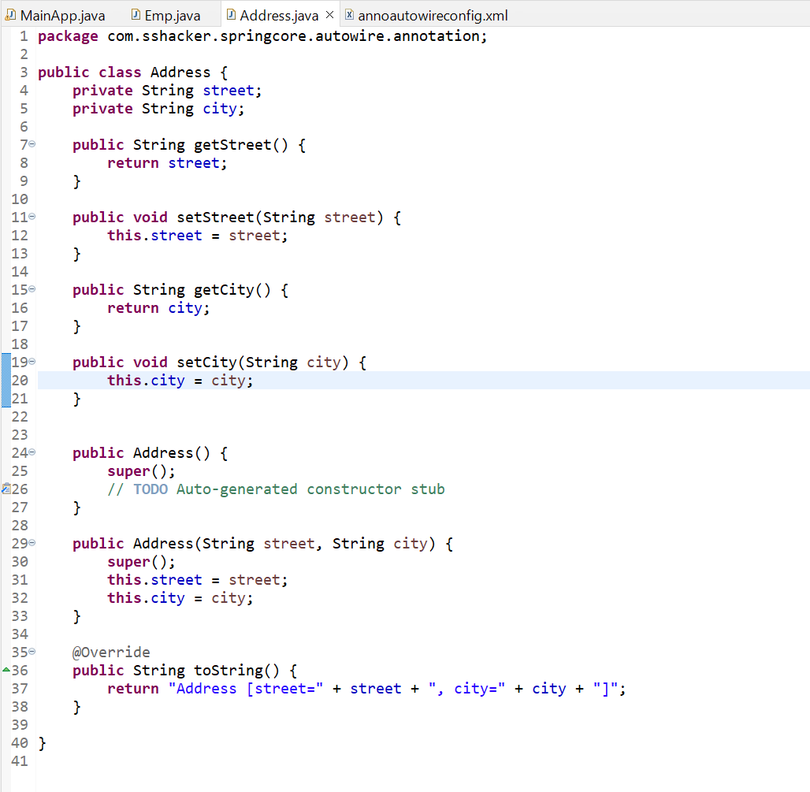

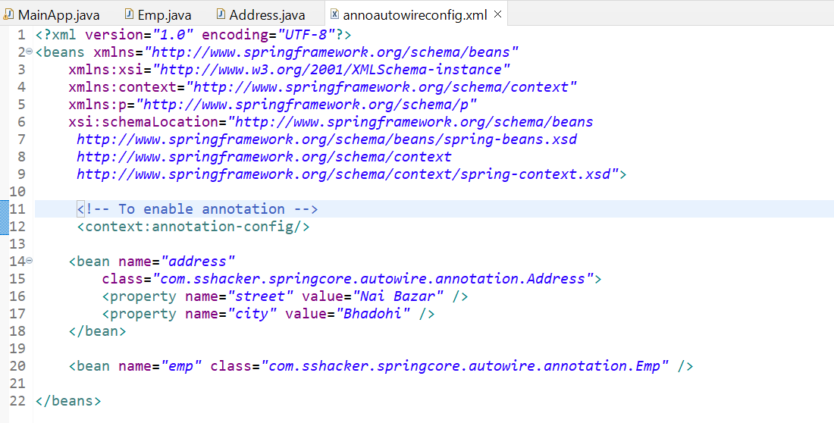

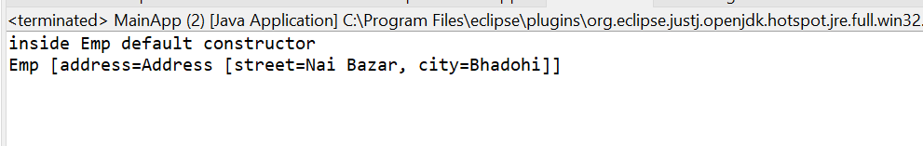

For setter: -

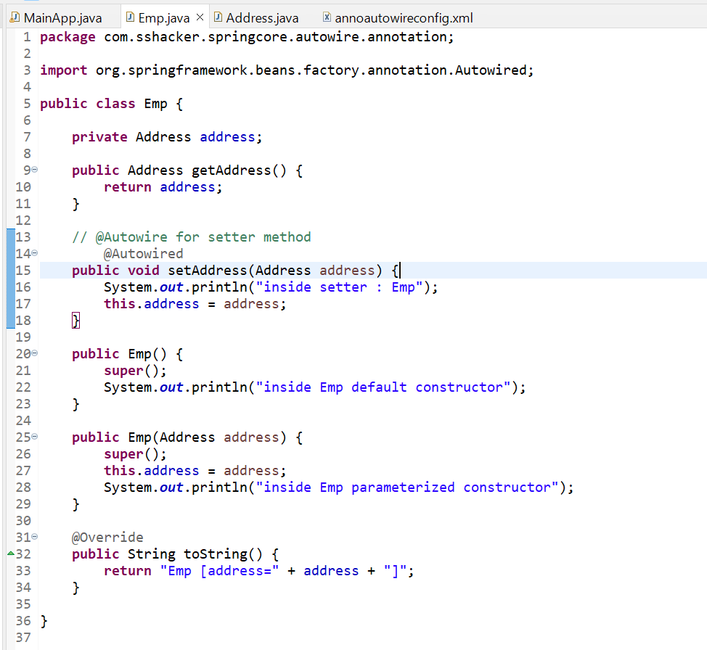

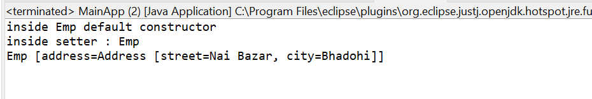

For constructor: -

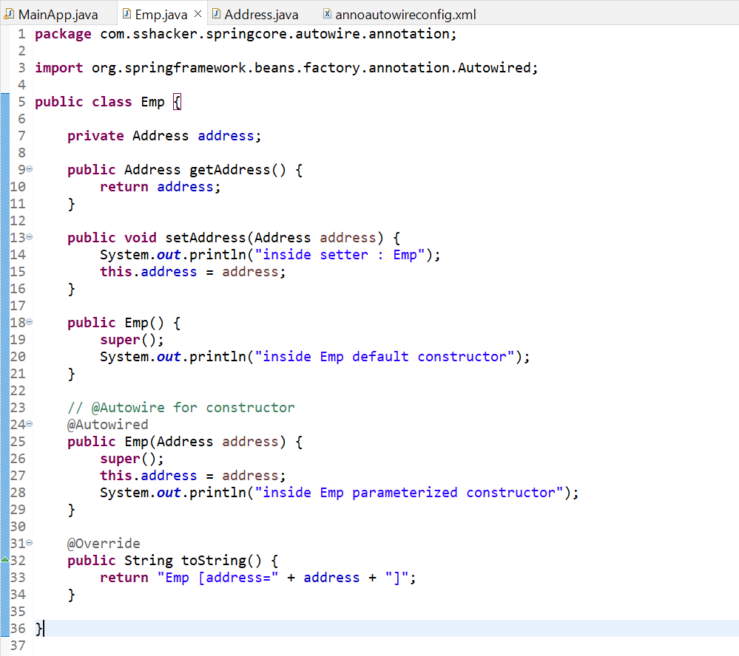

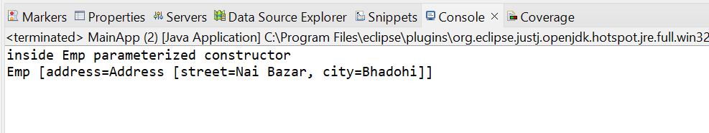

@Autowire is by default byType

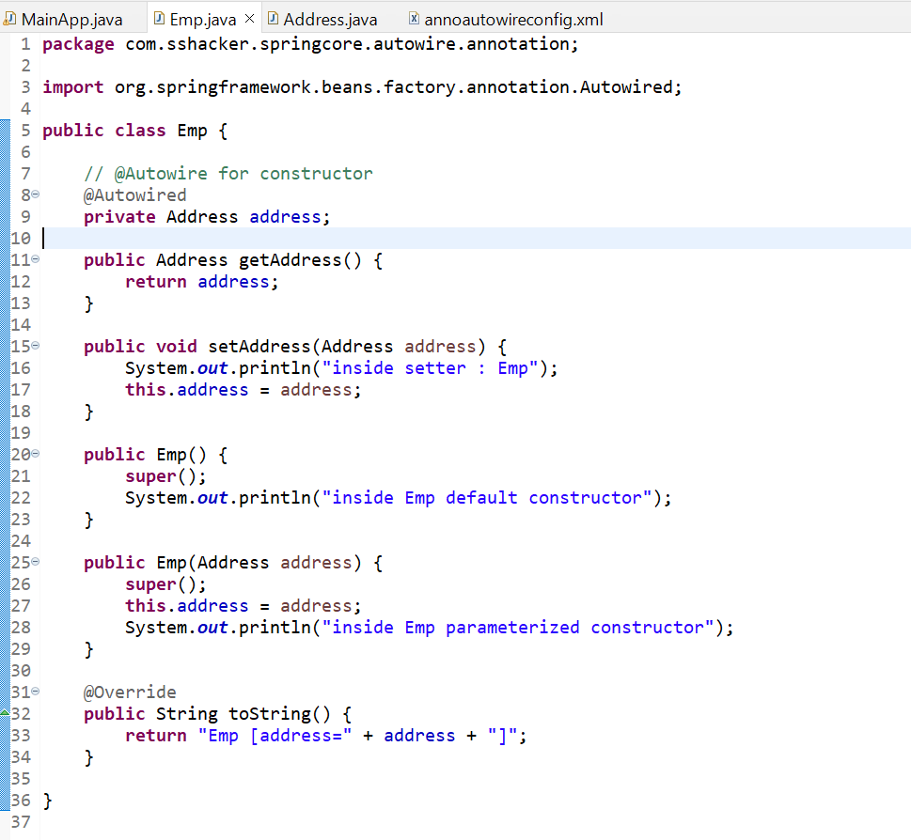

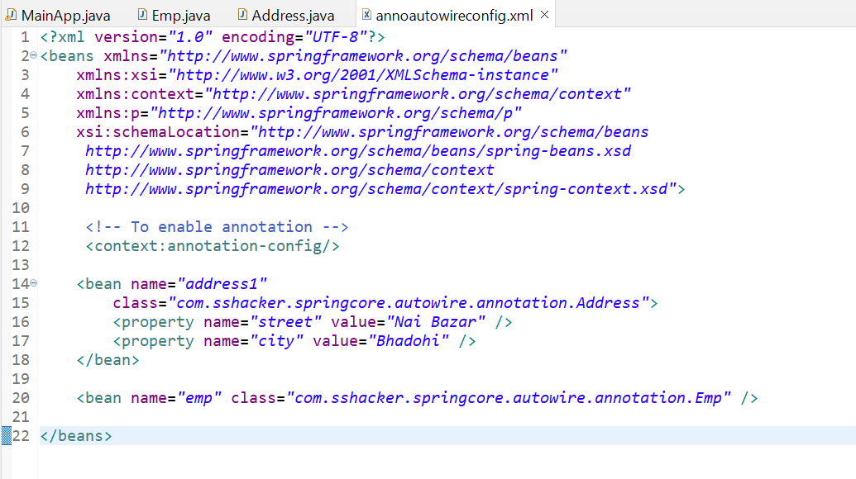

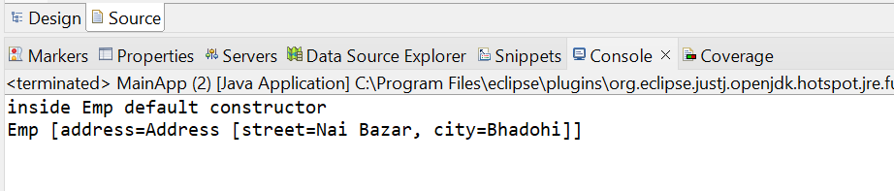

If same type 2 bean present in config.xml it will raise exception:-

NoUniqueBeanDefinitionException

